**Software Construction and Development**

**Project**

**Course Instructor**

Mr. Junaid Ali Khan

**Group Members**

Abdullah Daoud……………………………………………………….(22I-2626)

Ibrahim Kayani………………………………………….…………….(22I-2686)

**Section**

SE-E

**Date**

**Monday, May 12th, 2025**

**Spring 2025**



**Department of Software Engineering**

FAST – National University of Computer & Emerging Sciences

Islamabad Campus

Table of Contents

**Prerequisites 4**

**Environment Setup 4**

1. Operating System: Windows 11 4

2. Docker: Version 28.0.4 5

3. Minikube: Version v1.35.0 6

4. Kubectl: v1.32.0 / Kustomize: v5.5.0 7

**Commands Glossary 7**

**Step 1: Install Minikube and kubectl 18**

1.1 Install kubectl 18

1.2 Install Minikube 25

**Step 2: Develope a MERN Web App 32**

**Step 3: Containerize the Application with Docker 32**

3.1 Create Dockerfiles 32

3.1.1. Backend Dockerfile 32

3.1.2. Frontend Dockerfile 34

3.2 Build Docker Images 35

3.3 Test Docker Images Locally 36

**Issue 1 39**

**Issue Resolved 39**

**Step 4: Push Code to GitHub 39**

4.1 Initialize Git Repository 39

4.2 Create GitHub Repository 40

**Issue 2 41**

**Issue Resolved 41**

**Issue 3 42**

**Issue Resolved 42**

**Step 5: Create Kubernetes Deployment and Service Files 43**

5.1 Backend Deployment (k8s/backend-deployment.yaml) 43

5.2 Backend Service (k8s/backend-service.yaml) 44

5.3 Frontend Deployment (k8s/frontend-deployment.yaml) 45

5.4 Frontend Service (k8s/frontend-service.yaml) 46

5.5 MongoDB Service (k8s/mongo.yaml) 47

**Step 6: Start Minikube and Deploy the Application 49**

6.1 Start Minikube 49

6.2 Point Docker CLI to Minikube's Docker Daemon 50

**Issue 4 50**

**Issue Resolved 50**

**Step 7: Set Up Docker Hub 51**

**Step 8: Set Up GitHub Actions with a Self-Hosted Runner 53**

8.1 Add a Self-Hosted Runner 53

**Issue 5 58**

**Issue Resolved 58**

8.2 Create GitHub Actions Workflow 58

**Issue 6 68**

**Issue Resolved 69**

**Step 9: Trigger Local Deployment 69**

**Project Running Instructions 74**

# Prerequisites

Before diving into the project, ensure your system meets the following requirements:

* **Operating System**: Windows 10 or later
* **Hardware**: At least 2 CPUs, 2GB RAM, and 20GB free disk space
* **Software**:  
  + Docker Desktop
  + Node.js
  + [Git](https://git-scm.com/downloads)
  + [Visual Studio Code](https://code.visualstudio.com/)

# Environment Setup

* OS: Windows 11
* Minikube: minikube version: v1.35.0
* Kubectl: Client Version: v1.32.0, Kustomize Version: v5.5.0
* Docker: Docker version 28.0.4, build b8034c0

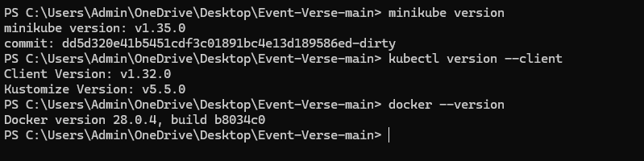

## 1. Operating System: Windows 11

* Windows 11 was selected because it was the default host OS available to our group members.
* It supports full GUI tooling, such as Docker Desktop and VS Code, and is compatible with Minikube using Hyper-V or VirtualBox.
* The OS also provides native PowerShell support, which was essential for configuring GitHub self-hosted runners.

Advantages

* GUI-Based Workflow: Simplified the use of Docker Desktop and other tools like Kubernetes dashboard.
* PowerShell Integration: Helped us follow GitHub’s Windows-specific instructions for self-hosted runners.
* File System Access: Made project navigation and editing easier with tools like VS Code and Git integration.

Challenges

* Shell Compatibility: Some common Unix commands like eval $(minikube docker-env) did not work, and we had to adapt by using:  
    
  & minikube -p minikube docker-env | Invoke-Expression
* GitHub Runner Setup: We faced additional prompts for permissions and user account setup when configuring the runner as a service.
* Long Path/Permission Limitations: GitHub recommended using C:\actions-runner to avoid Windows path and permission issues.

Impact on Workflow

* The initial setup required workarounds for certain commands.
* After the setup, the OS supported our development and deployment workflows effectively without further major issues.

## 2. Docker: Version 28.0.4

* We used Docker 28.0.4 because it was stable and up-to-date at the time of project execution.
* It offered compatibility with Windows 11, Docker Desktop, and our Minikube configuration.

Advantages

* **Local Image Building:** Enabled us to containerize the frontend and backend efficiently.
* **Integration with Minikube:** We leveraged Minikube’s local Docker environment, allowing image testing without pushing to Docker Hub.

Challenges

* We encountered a No such image error due to a tag mismatch and resolved it by listing and correctly referencing the image names using docker images.

Impact on Workflow

* Docker was central to our development and deployment.
* It helped us build and reuse containers across local and production-like environments.

## 3. Minikube: Version v1.35.0

* Minikube v1.35.0 was selected for its known compatibility with Windows and Docker.
* It enabled us to run a lightweight local Kubernetes cluster for end-to-end testing.

Advantages

* **Local Kubernetes Testing:** Allowed simulation of production-like environments.
* **Integration with Docker:** We could build images directly in the Minikube Docker daemon using:  
    
  & minikube -p minikube docker-env | Invoke-Expression

Challenges

* The original UNIX-style command eval $(minikube docker-env) was incompatible with PowerShell, requiring adjustments.
* We had to understand and configure NodePorts and services carefully to expose frontend (5173) and backend (5000) ports correctly.

Impact on Workflow

* Essential for Kubernetes testing and deployment validation.
* Allowed us to debug and fix deployment issues before CI/CD integration.

## 4. Kubectl: v1.32.0 / Kustomize: v5.5.0

* Kubectl v1.32.0 matched our Minikube version and was sufficient for applying and managing deployments.
* Kustomize, bundled with kubectl, allowed for future configuration layering if needed.

Advantages

* **Manual Control:** We used kubectl to apply YAML files, inspect pod statuses, and debug issues.
* **Resource Management:** Simplified our ability to interact with the cluster (get pods, logs, describe, etc.).

Impact on Workflow

* Allowed granular control during deployment testing.
* Helped in identifying configuration errors and validating service exposure.

**BEFORE PROCEEDING WITH ANY STEP, MAKE SURE DOCKER DESKTOP, MINIKUBE, KUBECTL AND SELF-HOSTED RUNNER USING THE ./run.cmd COMMAND IS RUNNING**

# Commands Glossary

This table lists all commands used in the this project for deploying a MERN application with Docker and Kubernetes, along with a one-line description of each command's purpose.

| **Command** | **Description** |
| --- | --- |
| **minikube version** | Displays the installed version of Minikube to verify its installation. |
| **kubectl version --client** | Shows the version of the kubectl client to confirm it is installed correctly. |
| **docker --version** | Outputs the installed Docker version to verify Docker is available. |
| **docker info --format '{{.ServerVersion}}'** | Retrieves the Docker server version in a formatted output. |
| **curl.exe -LO "https://dl.k8s.io/release/v1.33.0/bin/windows/amd64/kubectl.exe"** | Downloads the kubectl binary for Windows using curl. |
| **curl.exe -LO "https://dl.k8s.io/v1.33.0/bin/windows/amd64/kubectl.exe.sha256"** | Downloads the SHA256 checksum file for the kubectl binary to verify its integrity. |
| **CertUtil -hashfile kubectl.exe SHA256** | Generates the SHA256 hash of the kubectl binary for manual verification. |
| **type kubectl.exe.sha256** | Displays the contents of the kubectl checksum file for comparison. |
| **$(Get-FileHash -Algorithm SHA256 .\kubectl.exe).Hash -eq $(Get-Content .\kubectl.exe.sha256)** | Automates verification of the kubectl binary’s hash against its checksum file in PowerShell. |
| **cd Event-Verse-main** | Navigates to the root directory of the Event-Verse-3.0 project. |
| **cd backend** | Changes to the backend directory containing the Node.js application. |
| **cd ..** | Moves up one directory level in the file system. |
| **cd frontend** | Navigates to the frontend directory containing the React application. |
| **docker build -t your-dockerhub-username/mern-backend:latest .** | Builds a Docker image for the backend, tagging it with the user’s Docker Hub username. |
| **docker build -t your-dockerhub-username/mern-frontend:latest .** | Builds a Docker image for the frontend, tagging it with the user’s Docker Hub username. |
| **docker run -p 5000:5000 your-dockerhub-username/mern-backend:latest** | Runs the backend Docker container, mapping port 5000 to the host. |
| **docker run -p 5173:5173 your-dockerhub-username/mern-frontend:latest** | Runs the frontend Docker container, mapping port 5173 to the host. |
| **git init** | Initializes a new Git repository in the current directory. |
| **git add .** | Stages all files in the current directory for the next Git commit. |
| **git commit -m "Initial commit with MERN app and Dockerfiles"** | Commits staged changes with a message describing the initial MERN app setup. |
| **git remote add origin https://github.com/your-username/your-repo-name.git** | Sets the remote GitHub repository URL for pushing code. |
| **git branch -M main** | Renames the current branch to main. |
| **git push -u origin main** | Pushes the local main branch to the remote GitHub repository and sets upstream tracking. |
| **git branch --set-upstream-to=origin/main main** | Configures the local main branch to track the remote origin/main branch. |
| **git pull --rebase** | Fetches and integrates remote changes into the local branch using rebase to avoid merge commits. |
| **git push origin main** | Pushes local changes to the main branch of the remote GitHub repository. |
| **minikube start** | Starts a local Minikube Kubernetes cluster with the default driver. |
| **eval $(minikube docker-env)** | Configures the shell to use Minikube’s Docker daemon (Unix-style command). |
| **`& minikube -p minikube docker-env** | Invoke-Expression` |
| **docker info** | Displays detailed information about the Docker client and daemon, including the current environment. |
| **docker login** | Authenticates the Docker CLI with Docker Hub using user credentials. |
| **docker push your-username/mern-backend:latest** | Pushes the backend Docker image to the user’s Docker Hub repository. |
| **docker push your-username/mern-frontend:latest** | Pushes the frontend Docker image to the user’s Docker Hub repository. |
| **mkdir C:\actions-runner** | Creates a directory for the GitHub Actions self-hosted runner. |
| **cd C:\actions-runner** | Navigates to the GitHub Actions runner directory. |
| **Invoke-WebRequest -Uri https://github.com/actions/runner/releases/download/v2.323.0/actions-runner-win-x64-2.323.0.zip -OutFile actions-runner-win-x64-2.323.0.zip** | Downloads the GitHub Actions runner ZIP file for Windows. |
| **if((Get-FileHash -Path actions-runner-win-x64-2.323.0.zip -Algorithm SHA256).Hash.ToUpper() -ne 'E8CA92E3B1B907CDCC0C94640F4C5B23F377743993A4A5C859CB74F3E6EB33EF'.ToUpper()){ throw 'Computed checksum did not match' }** | Verifies the SHA256 hash of the downloaded runner ZIP file. |
| **Add-Type -AssemblyName System.IO.Compression.FileSystem** | Loads the .NET assembly for ZIP file operations in PowerShell. |
| **[System.IO.Compression.ZipFile]::ExtractToDirectory("$PWD\actions-runner-win-x64-2.323.0.zip", "$PWD")** | Extracts the GitHub Actions runner ZIP file to the current directory. |
| **./config.cmd --url https://github.com/Abdullah-57/Event-Verse-3.0 --token AXAAX43DNMVCFEP7U5ICE2LIECGKO** | Configures the self-hosted runner for the specified GitHub repository. |
| **./run.cmd** | Starts the GitHub Actions self-hosted runner as a process. |
| **git commit -m “Commit Message”** | Commits staged changes with a user-defined commit message. |
| **kubectl create namespace scd-project** | Creates a Kubernetes namespace named scd-project for the application. |
| **kubectl config set-context --current --namespace=scd-project** | Sets the current kubectl context to use the scd-project namespace. |
| **kubectl apply -f k8s/ --namespace=scd-project** | Applies all Kubernetes manifests in the k8s/ directory to the scd-project namespace. |
| **kubectl get pods** | Lists all pods in the current namespace to check their status. |
| **kubectl get svc** | Lists all services in the current namespace to verify service configuration. |
| **kubectl get deployments** | Lists all deployments in the current namespace to check deployment status. |
| **minikube service frontend-service -n scd-project** | Opens the frontend service in a browser using Minikube’s service access feature. |
| **minikube tunnel** | Creates a network tunnel to expose Minikube services externally. |
| **kubectl get svc --all-namespaces** | Lists all services across all namespaces in the Kubernetes cluster. |
| **kubectl get pods -n scd-project** | Lists pods specifically in the scd-project namespace. |
| **kubectl delete svc backend-service -n scd-project** | Deletes the backend service in the scd-project namespace. |
| **kubectl delete svc frontend-service -n scd-project** | Deletes the frontend service in the scd-project namespace. |
| **kubectl logs backend-68cc6d9f4f-c9sz5 -n scd-project** | Retrieves logs from the specified backend pod for troubleshooting. |
| **kubectl rollout restart deployment backend -n scd-project** | Restarts the backend deployment to apply updates or recover from issues. |
| **kubectl get pods -o wide** | Lists pods with additional details like node and IP addresses. |
| **npm install** | Installs Node.js dependencies listed in package.json. |
| **npm run dev** | Starts the React frontend development server using Vite. |
| **npm start** | Starts the Node.js backend server. |
| **kubectl create secret generic mongodb-secret --namespace scd-project --from-literal=uri=your-mongodb-uri** | Creates a Kubernetes secret for the MongoDB connection string. |
| **cd k8s** | Navigates to the k8s/ directory containing Kubernetes manifests. |
| **kubectl apply -f frontend-deployment.yaml** | Applies the frontend deployment manifest to the Kubernetes cluster. |
| **kubectl apply -f backend-deployment.yaml** | Applies the backend deployment manifest to the Kubernetes cluster. |
| **kubectl apply -f frontend-service.yaml** | Applies the frontend service manifest to the Kubernetes cluster. |
| **kubectl apply -f backend-service.yaml** | Applies the backend service manifest to the Kubernetes cluster. |
| **kubectl apply -f mongo.yaml** | Applies the MongoDB deployment and service manifest to the Kubernetes cluster. |
| **kubectl delete -f k8s/** | Deletes all resources defined in the k8s/ directory manifests. |
| **kubectl delete namespace scd-project** | Deletes the scd-project namespace and all its resources. |
| **minikube stop** | Stops the Minikube Kubernetes cluster. |
| **minikube start --driver=docker** | Starts Minikube with the Docker driver for container runtime. |
| **minikube status -p minikube** | Checks the status of the Minikube cluster. |
| **docker build -f frontend/Dockerfile -t abdullah577/mern-frontend:latest .** | Builds the frontend Docker image with a specific Dockerfile and tag. |
| **docker build -f backend/Dockerfile -t abdullah577/mern-backend:latest .** | Builds the backend Docker image with a specific Dockerfile and tag. |

**IF YOU WANT A GUIDE ON HOW TO USE EACH COMMAND, REFER TO THE COMMANDS GLOSSARY**

# Step 1: Install Minikube and kubectl

## 1.1 Install kubectl

kubectl is the command-line tool for interacting with Kubernetes clusters.

Go to the following website and click on “[Install kubectl binary on Windows (via direct download or curl](https://kubernetes.io/docs/tasks/tools/install-kubectl-windows/#install-kubectl-binary-on-windows-via-direct-download-or-curl))”

https://kubernetes.io/docs/tasks/tools/install-kubectl-windows/#install-kubectl-binary-on-windows-via-direct-download-or-curl

Using curl:

curl.exe -LO "https://dl.k8s.io/release/v1.33.0/bin/windows/amd64/kubectl.exe"

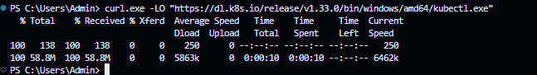

Validating the binary  
Download the kubectl checksum file:

curl.exe -LO "https://dl.k8s.io/v1.33.0/bin/windows/amd64/kubectl.exe.sha256"

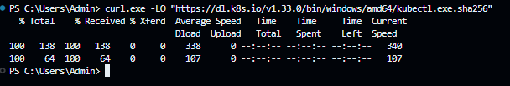

Validating the kubectl binary against the checksum file:

Using Command Prompt to manually compare CertUtil's output to the checksum file downloaded:

CertUtil -hashfile kubectl.exe SHA256

**type** kubectl.exe.sha256

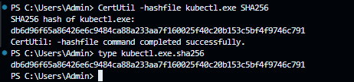

Using PowerShell to automate the verification using the -eq operator to get a True or False result:

$(Get-FileHash -Algorithm SHA256 .\kubectl.exe).Hash -eq $(Get-Content .\kubectl.exe.sha256)



Add the kubectl.exe to the PATH environment variable.

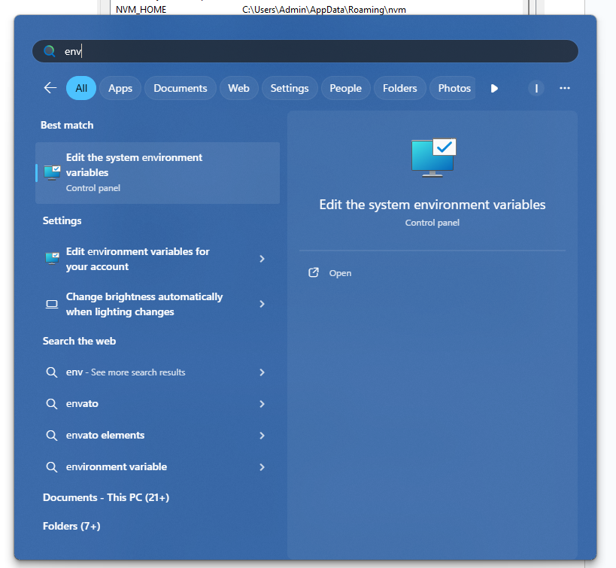

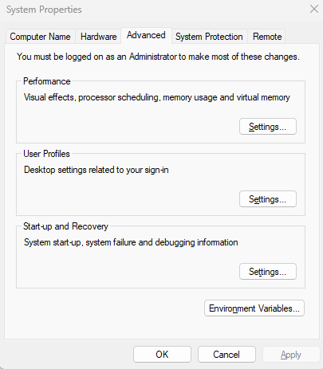

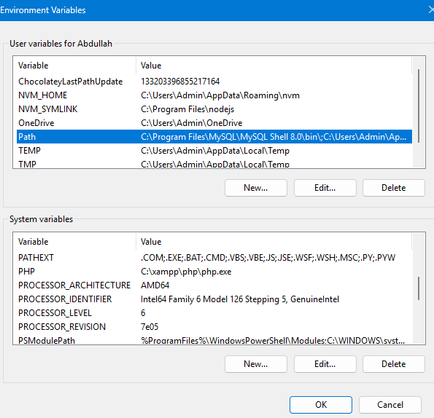

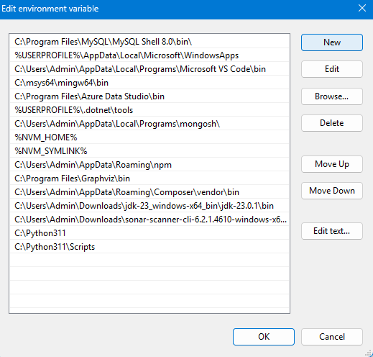

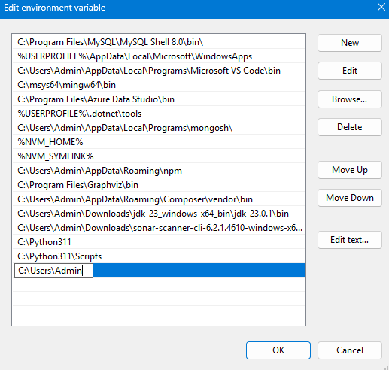

Testing to ensure the version of kubectl is the same as downloaded:

kubectl version --client

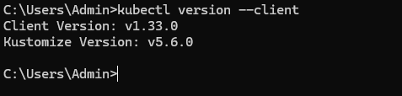

## 1.2 Install Minikube

Minikube allows you to run a single-node Kubernetes cluster locally.

Go to the following website and select the Windows Operating System and Installer type as .exe

<https://minikube.sigs.k8s.io/docs/start/?arch=%2Fwindows%2Fx86-64%2Fstable%2F.exe+download>

Click on the “[latest release](https://storage.googleapis.com/minikube/releases/latest/minikube-installer.exe)” to download the Minikube Installer

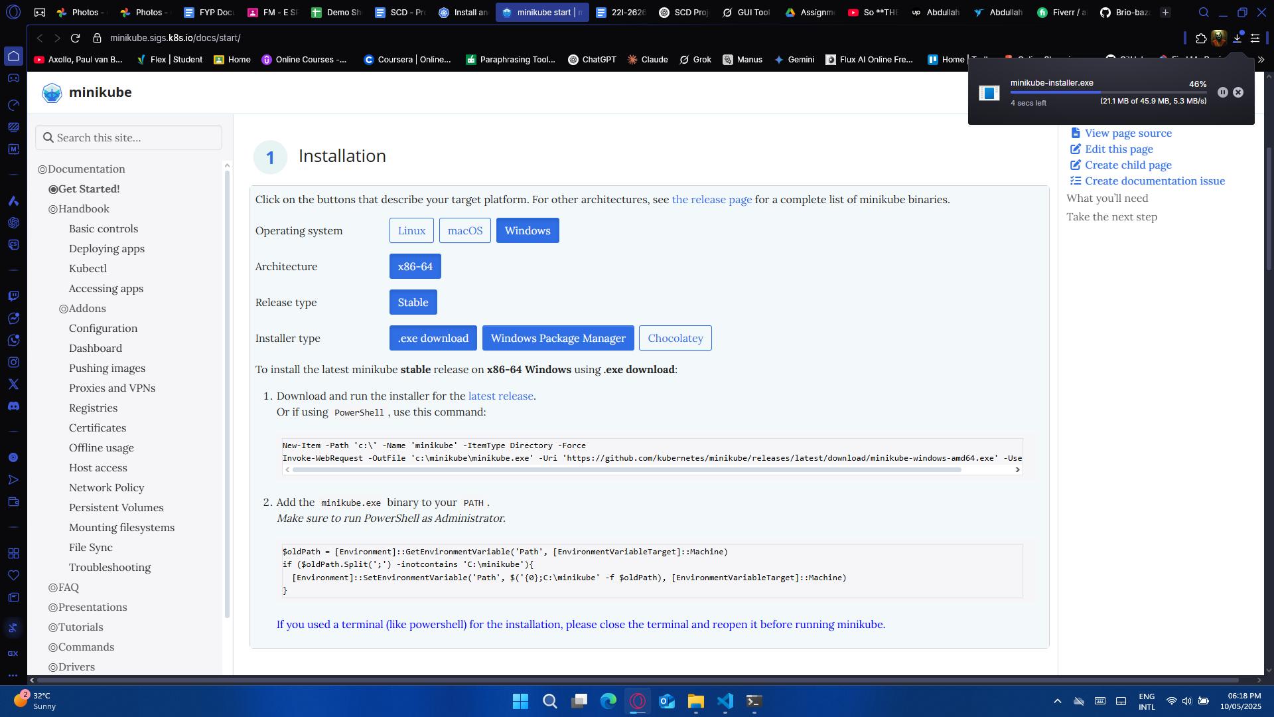

Run the installer and follow the on-screen instructions.

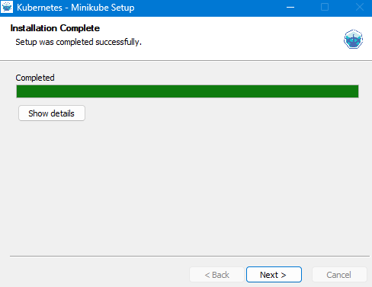

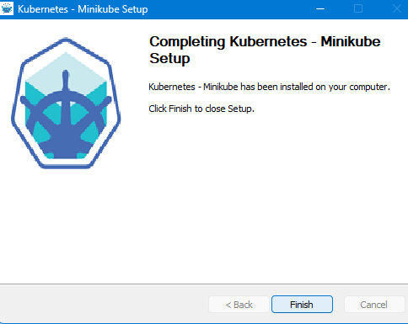

Add Minikube.exe to the PATH environment variable.









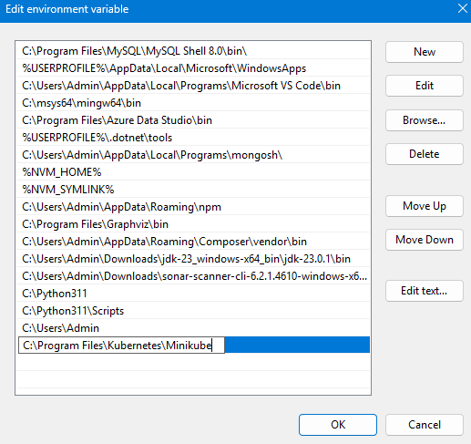

Verify if Minikube is accessible by opening a new Command Prompt or PowerShell window and running:

minikube version

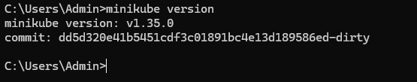

You should see the installed version of Minikube.

# Step 2: Develope a MERN Web App

For this project, we will be re-using our MERN Web App from previous semester’s Web Engineering Project, below is the link to the Github Repository:

https://github.com/Abdullah-57/Event-Verse-3.0

Project Structure of this MEN Web App (currently) is:

Event-Verse-main/

├── backend/

├── frontend/

├── node_modules

├── .gitignore

├── package-lock.json

├── package.json

# Step 3: Containerize the Application with Docker

## 3.1 Create Dockerfiles

You'll need separate Dockerfiles for the frontend and backend.

### 3.1.1. Backend Dockerfile

Navigate to the backend directory

cd Event-Verse-main

cd backend

Create the Dockerfile

Add the following code to the Dockerfile:

# Use official Node.js LTS image

FROM node:18

# Set working directory

WORKDIR /app

# Copy package.json and package-lock.json

COPY package*.json ./

# Install dependencies

RUN npm install

# Copy the rest of the application code

COPY . .

# Expose the backend port

EXPOSE 5000

# Start the backend server

CMD ["npm", "start"]

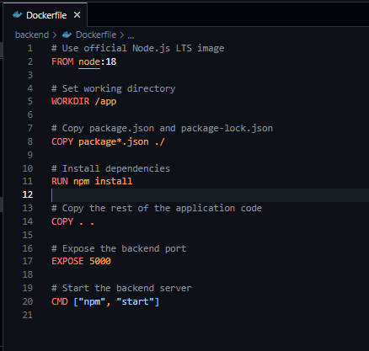

### 3.1.2. Frontend Dockerfile

Navigate to the frontend directory

cd ..

cd frontend

Create the Dockerfile

Add the following code ro the Dockerfile:

# Frontend Dockerfile

FROM node:18

# Set working directory

WORKDIR /app

# Copy package.json and package-lock.json

COPY package*.json ./

# Install dependencies

RUN npm install

# Copy the rest of the application code

COPY . .

# Expose the frontend port

EXPOSE 5173

# Start the frontend server

CMD ["npm", "run", "dev"]

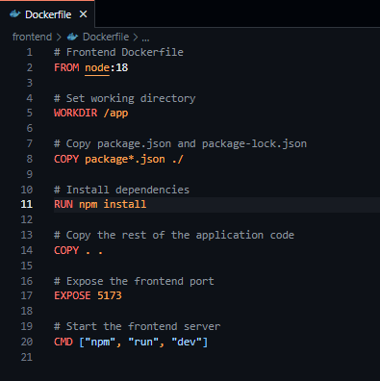

## 3.2 Build Docker Images

Open a terminal and navigate to the backend directory:

cd Event-Verse-main

cd backend

docker build -t your-dockerhub-username/mern-backend:latest .

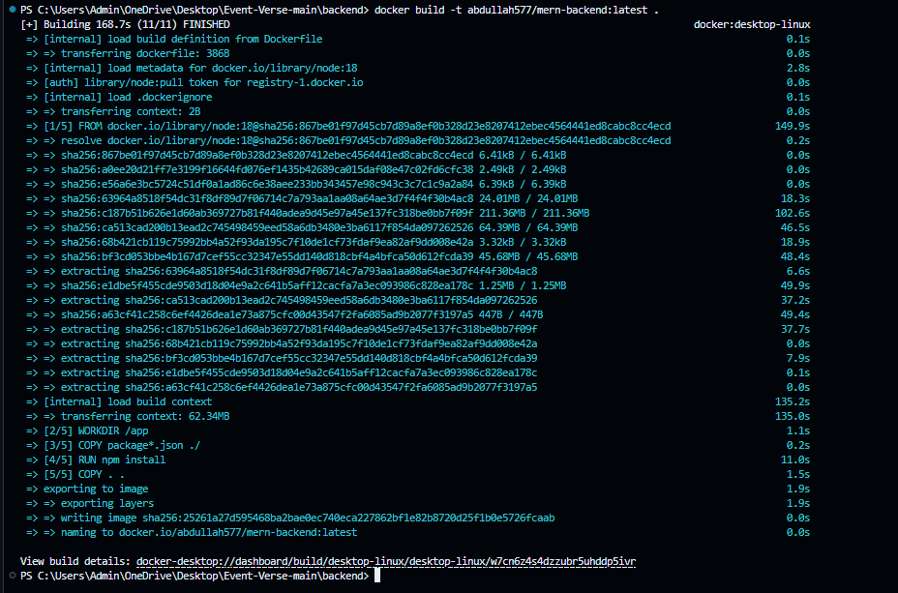

Then, navigate to the frontend directory:

cd ..

cd frontend

docker build -t your-dockerhub-username/mern-frontend:latest .

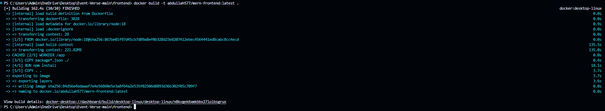

**Replace your-dockerhub-username with your actual Docker Hub username.**

## 3.3 Test Docker Images Locally

Run the backend container:

docker run -p 5000:5000 your-dockerhub-username/mern-backend:latest

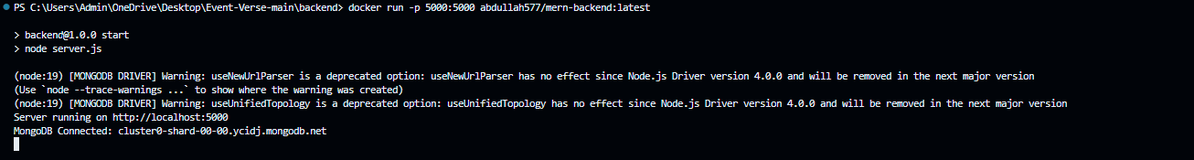

In a new terminal, run the frontend container:

docker run -p 5173:5173 your-dockerhub-username/mern-frontend:latest

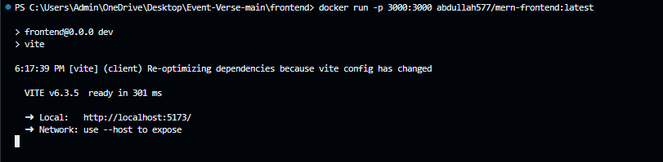



Visit <http://localhost:5173> in your browser to verify the frontend is working and communicating with the backend.

**Replace your-dockerhub-username with your actual Docker Hub username.**

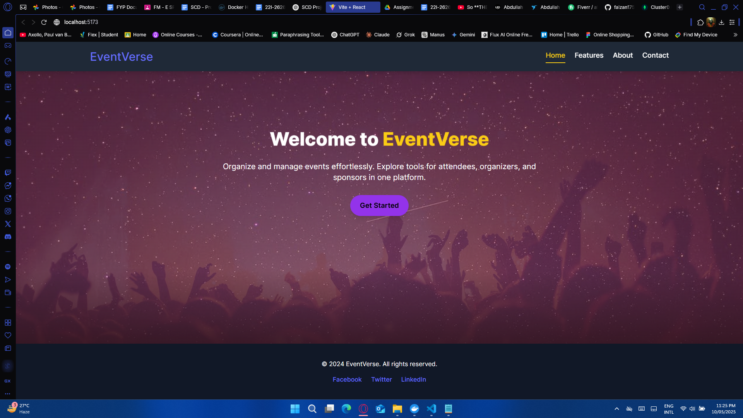

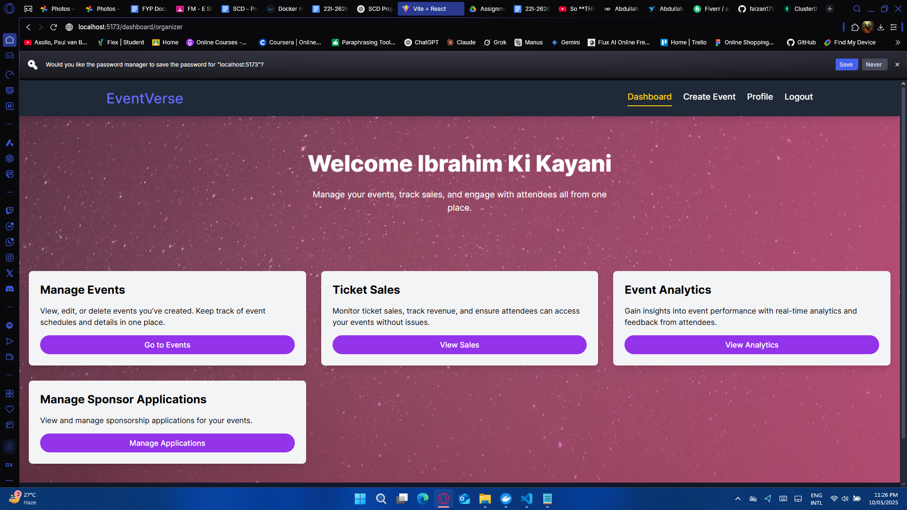

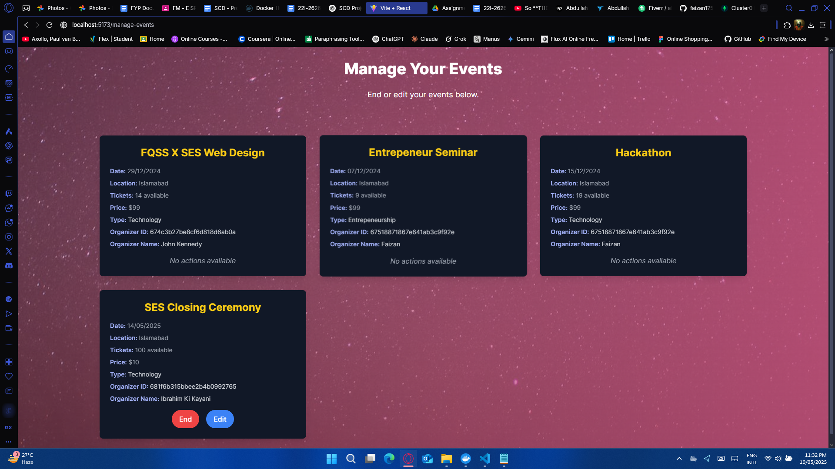

Logging into:

Email: [ibrahimkikayani@gmail.com](mailto:ibrahimkikayani@gmail.com)

Password: 123

Role: Organizer

Proves that the MERN Web App is containerized and the backend and frontend are communicating with each other

# Issue 1

Unable to access the app on localhost after running the containers

# Issue Resolved

Added the following line of code

"scripts": {

"dev": "vite --host"

}

in frontend’s package.json file to make the Vite dev server bind to localhost (inside the container), which isn’t accessible from outside (Dockerfile) unless explicitly told

# Step 4: Push Code to GitHub

## 4.1 Initialize Git Repository

If you haven't already, initialize a Git repository in your project root:

cd Event-Verse-main

git init

git add .

git commit -m "Initial commit with MERN app and Dockerfiles"

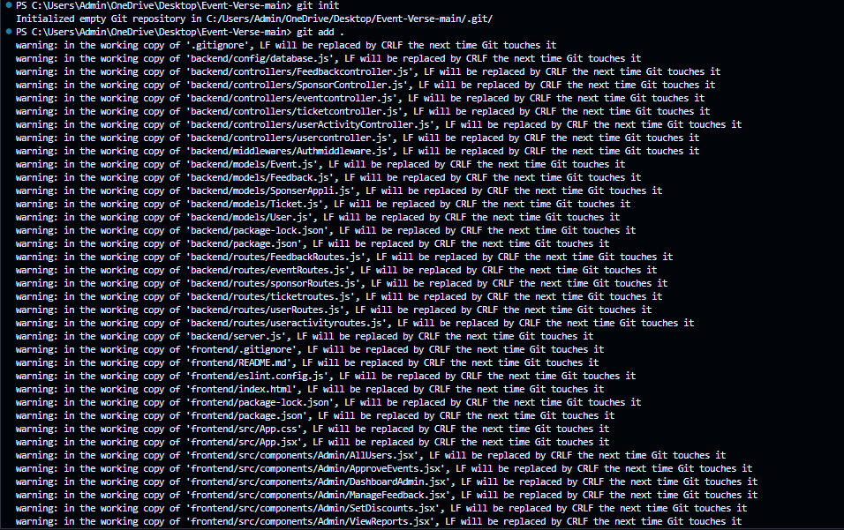

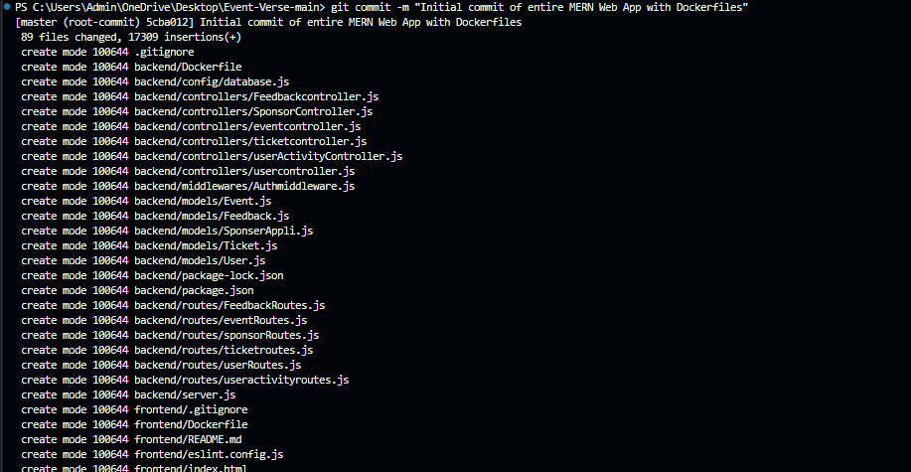

## 4.2 Create GitHub Repository

Go to [GitHub](https://github.com/) and create a new repository

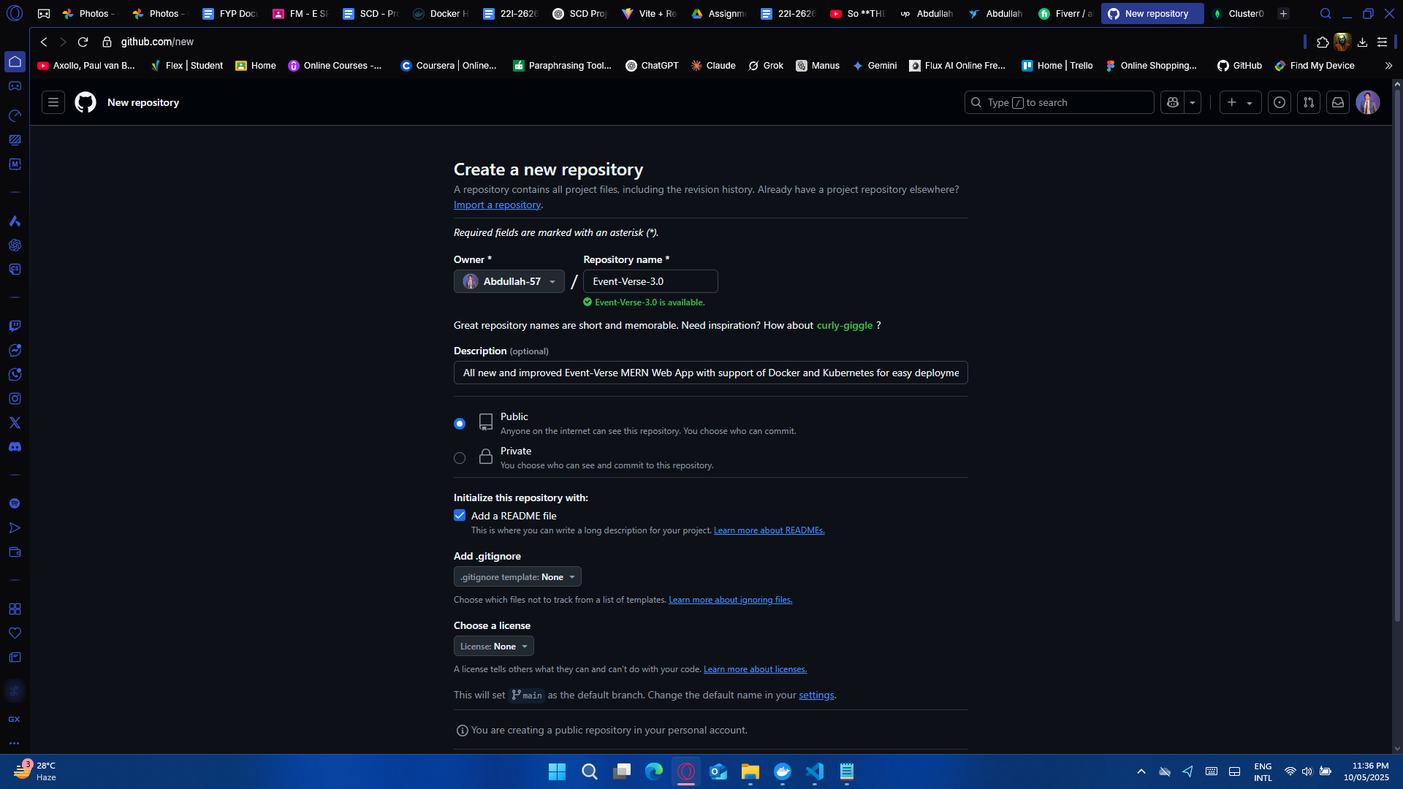

Add the local commit to the remote repository:  
  
git remote add origin <https://github.com/your-username/your-repo-name.git>

**Replace your-username with your github username and your-repo-name with your github repository name**

git remote add origin <https://github.com/your-username/your-repo-name.git>

git branch -M main

git push -u origin main

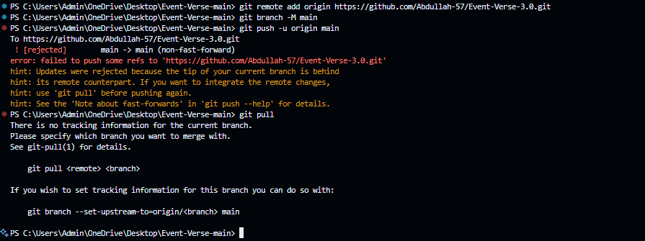

# Issue 2

This error means that the GitHub repo (Event-Verse-3.0) already has commits, and the local branch is behind or not in sync. Git is blocking the push to avoid overwriting what's on the remote

# Issue Resolved

Run the following commands:

Set up tracking for the main branch

git branch --set-upstream-to=origin/main main

Pull the remote branch (and auto-merge if no conflicts)

git pull --rebase

Now push the local changes

git push origin main

# Issue 3

Git blocking a push to remote repo due to exposing a stripe secret key

# Issue Resolved

Shifted the secret key from the [eventController.js](http://eventcontroller.js) file to the .env file and then pushed the code to remote repo

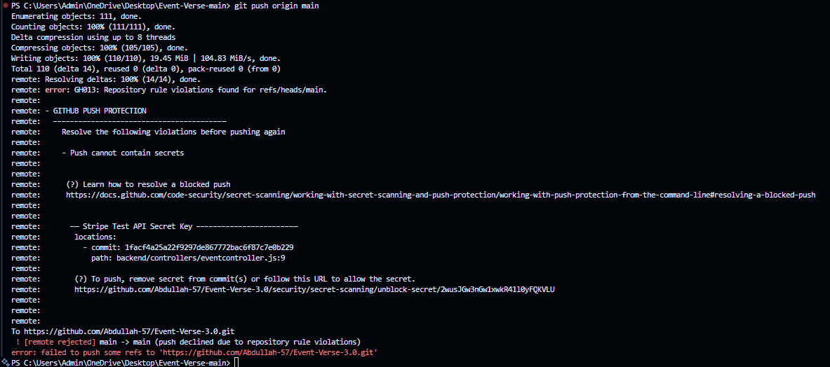

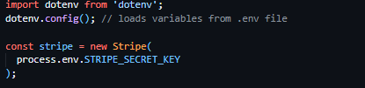

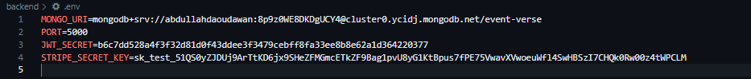

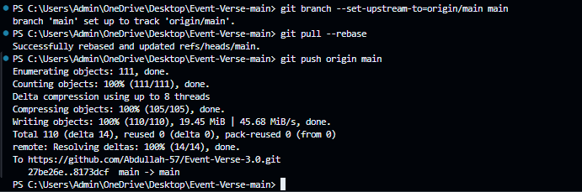

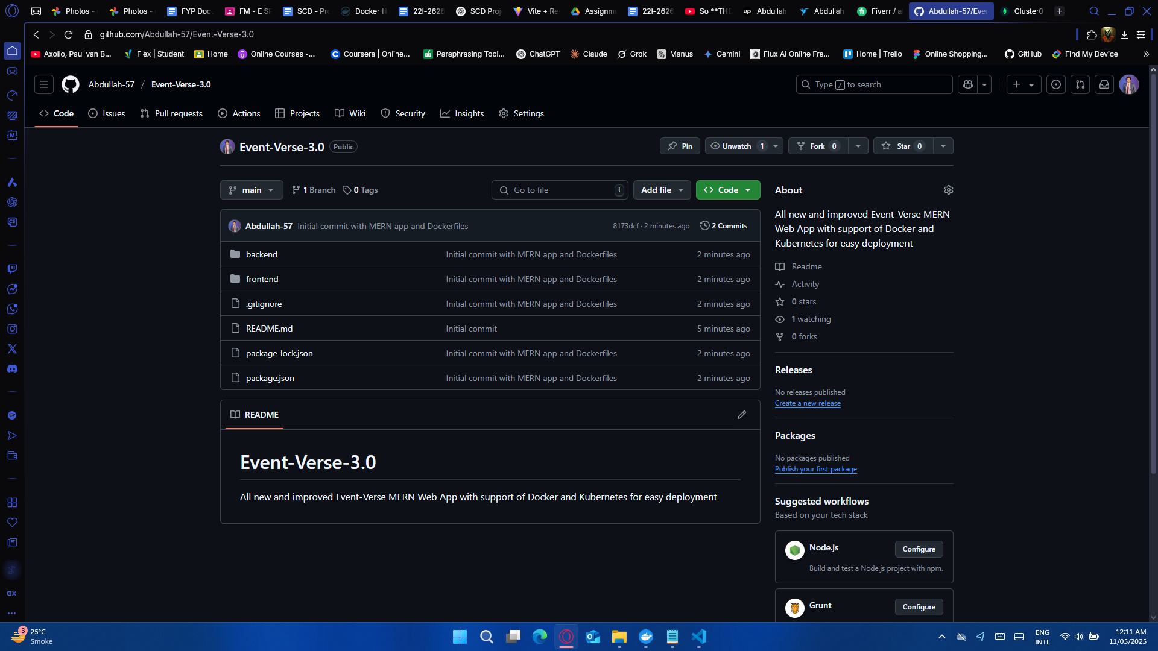

# Step 5: Create Kubernetes Deployment and Service Files

Create a k8s/ directory in your project root to store Kubernetes service and deployment files

## 5.1 Backend Deployment (k8s/backend-deployment.yaml)

apiVersion: apps/v1

kind: Deployment

metadata:

name: backend

spec:

replicas: 2

selector:

matchLabels:

app: backend

template:

metadata:

labels:

app: backend

spec:

containers:

- name: backend

image: abdullah577/mern-backend:latest

ports:

- containerPort: 5000

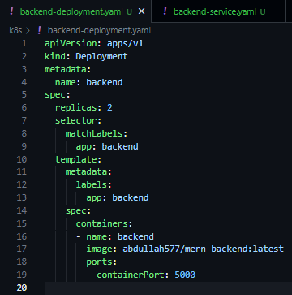

## 5.2 Backend Service (k8s/backend-service.yaml)

apiVersion: v1

kind: Service

metadata:

name: backend-service

spec:

type: NodePort

selector:

app: backend

ports:

- port: 5000

targetPort: 5000

nodePort: 30001

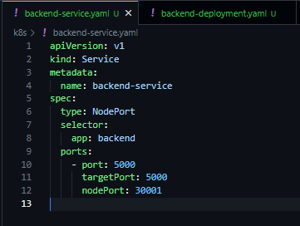

## 5.3 Frontend Deployment (k8s/frontend-deployment.yaml)

apiVersion: apps/v1

kind: Deployment

metadata:

name: frontend

spec:

replicas: 2

selector:

matchLabels:

app: frontend

template:

metadata:

labels:

app: frontend

spec:

containers:

- name: frontend

image: abdullah577/mern-frontend:latest

ports:

- containerPort: 5173

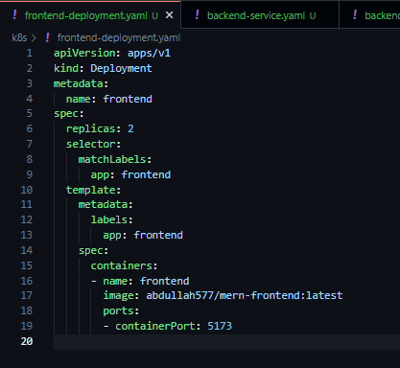

## 5.4 Frontend Service (k8s/frontend-service.yaml)

apiVersion: v1

kind: Service

metadata:

name: frontend-service

spec:

type: NodePort

selector:

app: frontend

ports:

- port: 5173

targetPort: 5173

nodePort: 30002

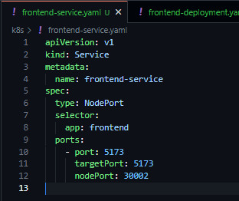

## 5.5 MongoDB Service (k8s/mongo.yaml)

---

apiVersion: apps/v1

kind: Deployment

metadata:

name: mongo

labels:

app: mongo

spec:

replicas: 1

selector:

matchLabels:

app: mongo

template:

metadata:

labels:

app: mongo

spec:

containers:

- name: mongo

image: mongo:6

ports:

- containerPort: 27017

volumeMounts:

- name: mongo-data

mountPath: /data/db

volumes:

# For persistence in Minikube demo you can use emptyDir

- name: mongo-data

emptyDir: {}

---

apiVersion: v1

kind: Service

metadata:

name: mongo

spec:

selector:

app: mongo

ports:

- port: 27017

targetPort: 27017

clusterIP: None # headless service if you want direct pod access

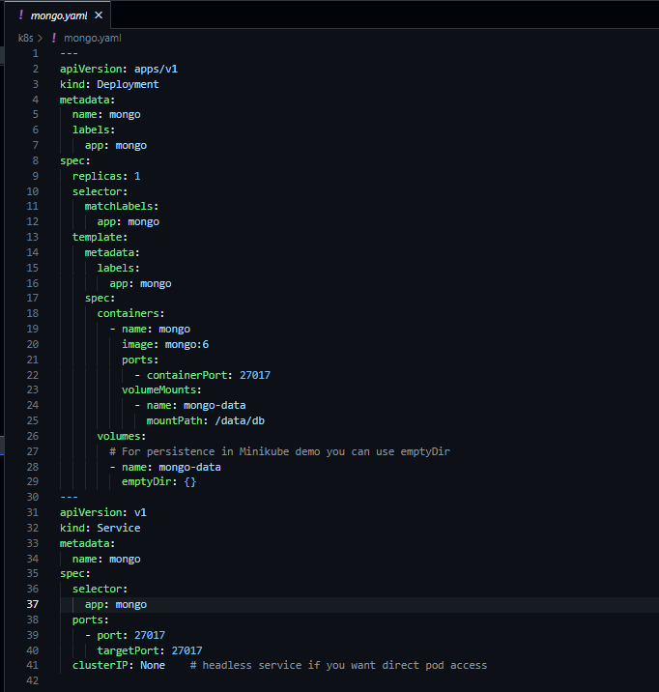

# Step 6: Start Minikube and Deploy the Application

## 6.1 Start Minikube

Open a terminal and start Minikube:

minikube start

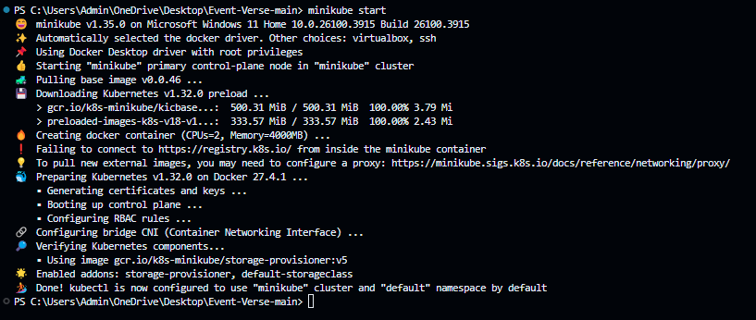

## 6.2 Point Docker CLI to Minikube's Docker Daemon

To use Minikube's Docker daemon:

eval $(minikube docker-env)

This allows you to build Docker images directly inside Minikube's environment.

# Issue 4

eval $(minikube docker-env) is a Unix-Shell command, not a Powershell or Windows command

# Issue Resolved

Using its equivalent Powershell/Windows command

& minikube -p minikube docker-env | Invoke-Expression

and verifying using

docker info

Look for a line that says “Name: minikube”

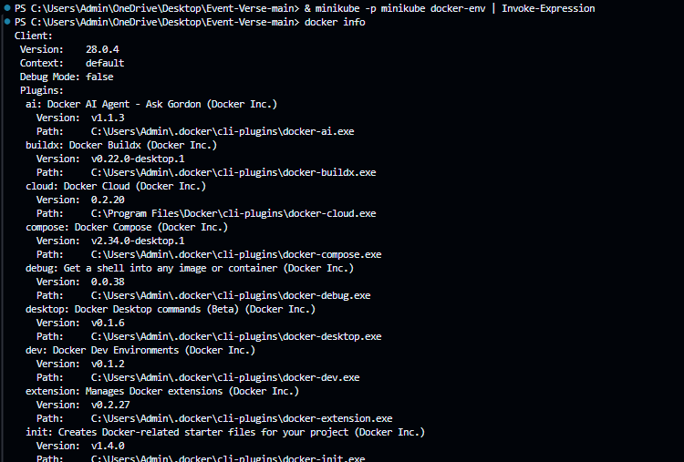

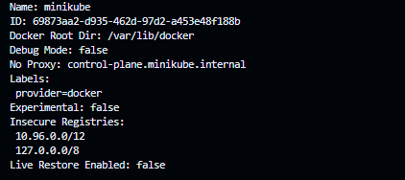

# Step 7: Set Up Docker Hub

Create an account on Docker Hub if you haven't already.

Log in to Docker Hub from your terminal:  
  
docker login

Push your Docker images:

docker push your-username/mern-backend:latest

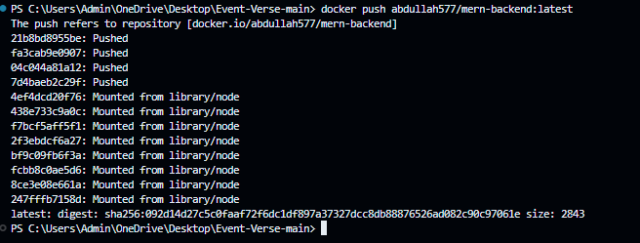

docker push your-username/mern-frontend:latest

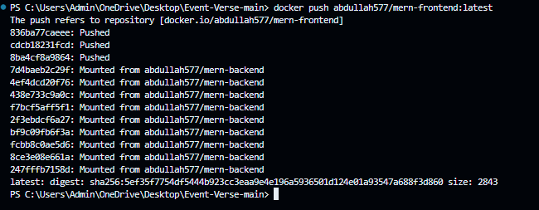

**Replace your-username with your github username and your-repo-name with your github repository name**

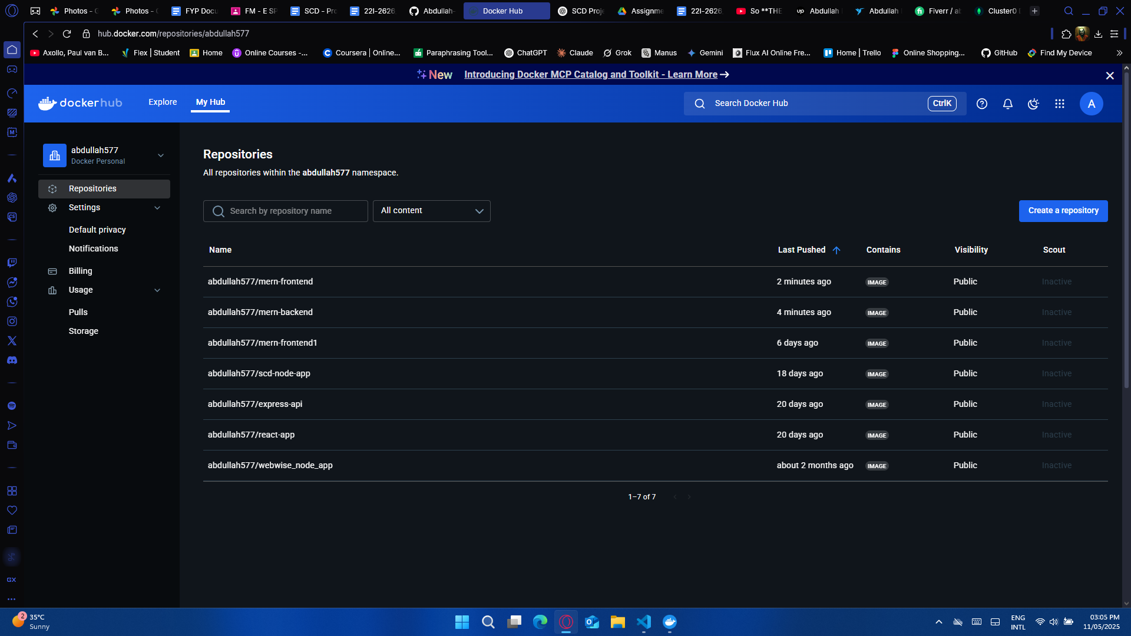

# Step 8: Set Up GitHub Actions with a Self-Hosted Runner

## 8.1 Add a Self-Hosted Runner

Navigate to your GitHub repository.

Click on "Settings" > "Actions" > "Runners".

Click on "New self-hosted runner".

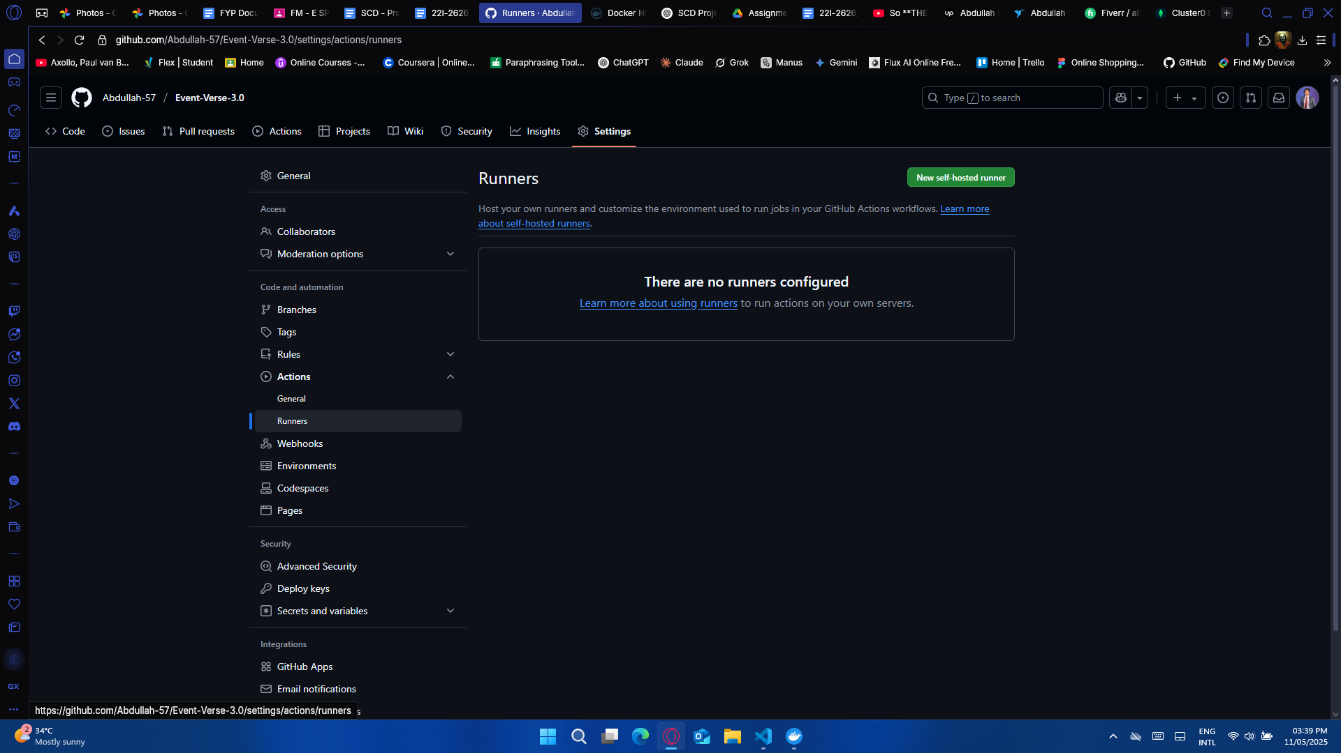

Choose your operating system and architecture.

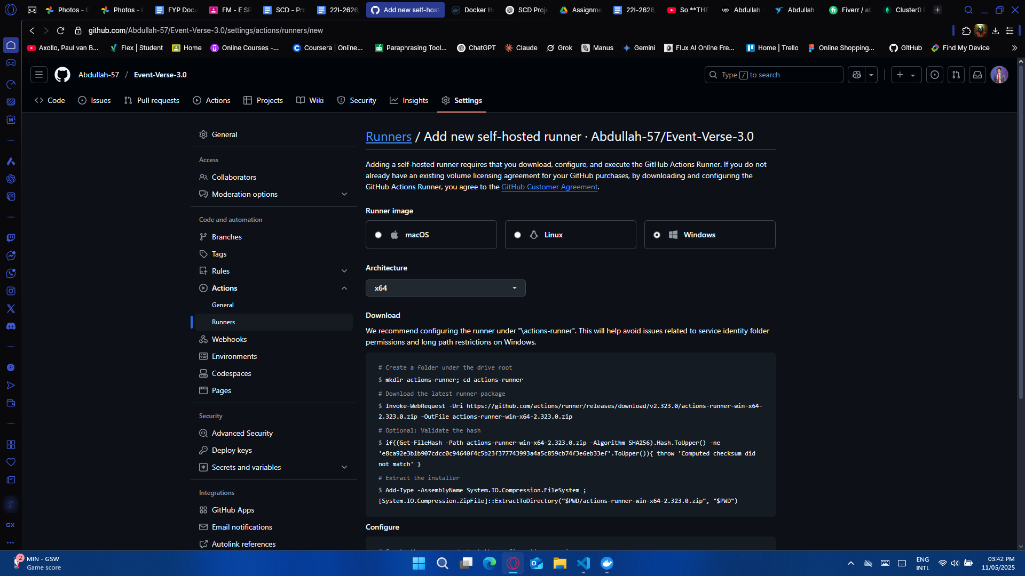

Follow the provided instructions to download and configure the runner on your local machine.

Open a Terminal

Open PowerShell as Administrator (search "PowerShell", right-click → "Run as Administrator").

Alternatively, you can use VS Code terminal, but PowerShell outside VS Code is more reliable for this setup.

Create a Folder and Move Into It

mkdir C:\actions-runner

cd C:\actions-runner

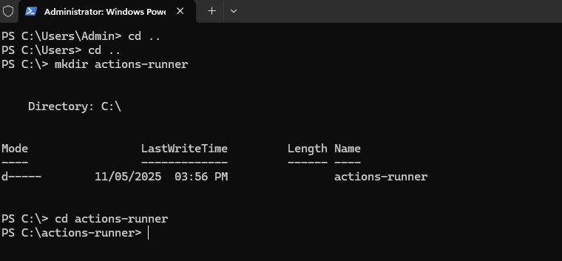

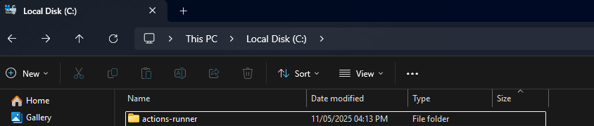

Download the Runner ZIP

Invoke-WebRequest -Uri https://github.com/actions/runner/releases/download/v2.323.0/actions-runner-win-x64-2.323.0.zip -OutFile actions-runner-win-x64-2.323.0.zip



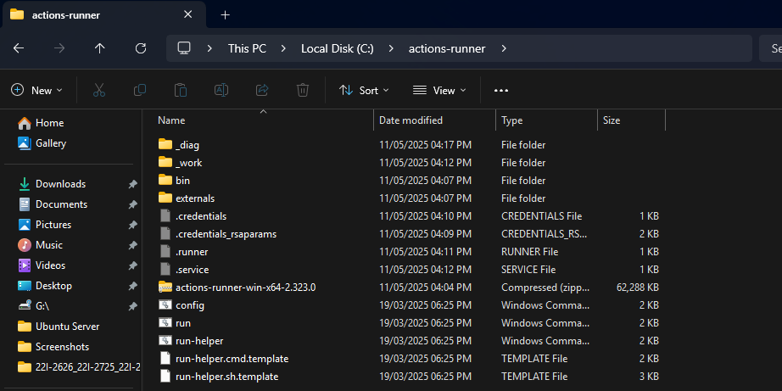

Verify the File's SHA256

if((Get-FileHash -Path actions-runner-win-x64-2.323.0.zip -Algorithm SHA256).Hash.ToUpper() -ne 'E8CA92E3B1B907CDCC0C94640F4C5B23F377743993A4A5C859CB74F3E6EB33EF'.ToUpper()){ throw 'Computed checksum did not match' }



Extract the ZIP

Add-Type -AssemblyName System.IO.Compression.FileSystem

[System.IO.Compression.ZipFile]::ExtractToDirectory("$PWD\actions-runner-win-x64-2.323.0.zip", "$PWD")



Configure the Runner

Replace <your-token> with the actual token shown in your GitHub repo:

./config.cmd --url https://github.com/Abdullah-57/Event-Verse-3.0 --token AXAAX43DNMVCFEP7U5ICE2LIECGKO

After that, it will ask you a few setup questions — just keep pressing ENTER

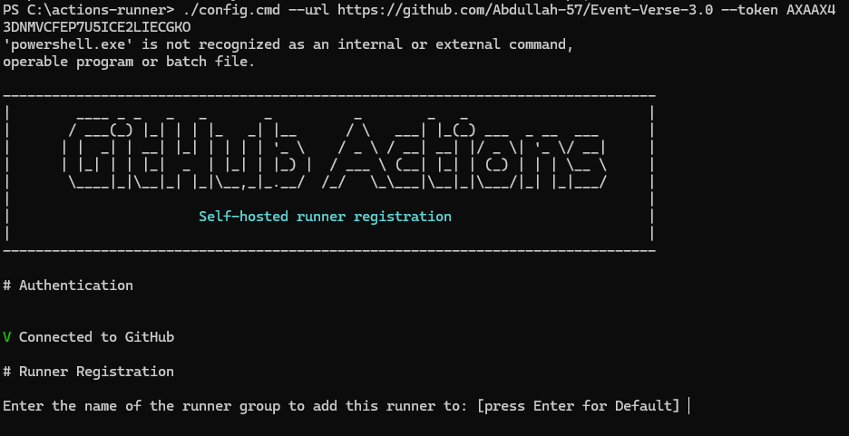

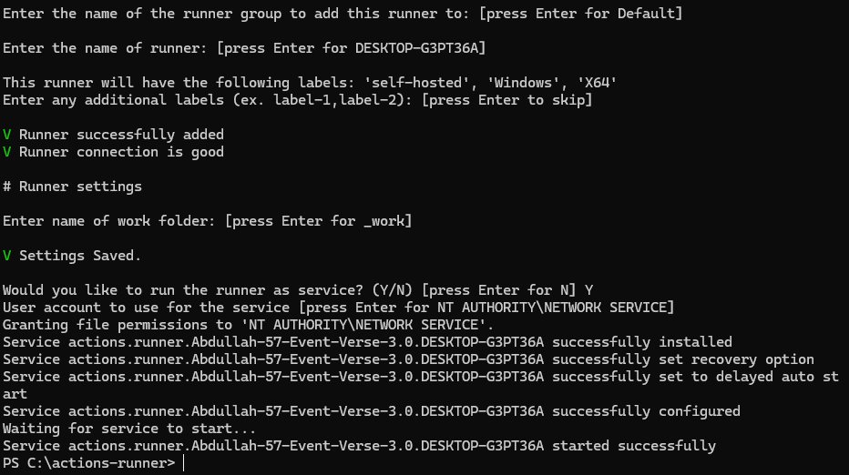

Pressed Y for ‘runner as a service’ which configured the runner to listen for jobs automatically when system is booted (caused an issue which is fixed later)

If configured runner as a service like in the above step, then skip the below command, otherwise

Start the Runner

./run.cmd

You will now see logs like:

√ Connected to GitHub

Listening for Jobs…

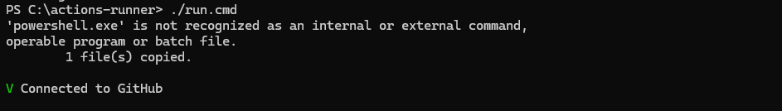

Keep this PowerShell window **open and running** — it needs to stay running to accept jobs from GitHub Actions.

# Issue 5

Originally configured self-hosted runner as a windows service that turns on automatically when system is booted, this caused an unexpected issue where the workflow was unable to be triggered due to shell compatibility errors where no type of shell environment worked e.g

pwsh: command not found

powershell: command not found

bash: command not found

# Issue Resolved

Follow the steps given above and keep pressing ENTER once you reach the point where the shell asks you questions to configure your runner, ENTER lets you skip everything and use default options

## 8.2 Create GitHub Actions Workflow

Create a .github/workflows/deploy.yml file in your repository:

Create this inside your repo:

Event-Verse-3.0/

└── .github/

└── workflows/

└── deploy.yaml ← Create this file here

If .github or workflows folder doesn't exist, just create them.

**deploy.yaml**

name: Build and Deploy to Minikube

on:

push:

branches:

- main

jobs:

build-deploy:

runs-on: self-hosted

steps:

- name: Checkout code

uses: actions/checkout@v3

- name: Start Minikube

shell: powershell

run: |

Write-Output "Starting Minikube..."

minikube start --driver=docker

if ($LASTEXITCODE -ne 0) {

Write-Error "Failed to start Minikube"

exit 1

}

Write-Output "Minikube started successfully"

- name: Verify Minikube and Docker

shell: powershell

run: |

Write-Output "Checking Minikube and Docker installation..."

minikube version

docker --version

docker info --format '{{.ServerVersion}}'

Write-Output "Checking Minikube status..."

$status = minikube status -p minikube

if ($LASTEXITCODE -ne 0) {

Write-Error "Minikube is not running or accessible"

exit 1

}

Write-Output "Minikube is running"

- name: Set up Docker to use Minikube's environment

shell: powershell

run: |

Write-Output "Configuring Docker to use Minikube's environment..."

& minikube -p minikube docker-env --shell powershell | Invoke-Expression

if ($LASTEXITCODE -ne 0) {

Write-Error "Failed to set up Minikube Docker environment"

exit 1

}

Write-Output "Docker environment set up successfully"

- name: Log in to Docker Hub

uses: docker/login-action@v3

with:

username: ${{ secrets.DOCKER_USERNAME }}

password: ${{ secrets.DOCKER_PASSWORD }}

- name: Build and Push Frontend Docker Image

shell: powershell

run: |

docker build -f frontend/Dockerfile -t abdullah577/mern-frontend:latest .

docker push abdullah577/mern-frontend:latest

- name: Build and Push Backend Docker Image

shell: powershell

run: |

docker build -f backend/Dockerfile -t abdullah577/mern-backend:latest .

docker push abdullah577/mern-backend:latest

- name: Deploy to Minikube

shell: powershell

run: |

Write-Output "Deploying to Minikube..."

kubectl apply -f k8s/frontend-deployment.yaml

kubectl apply -f k8s/frontend-service.yaml

kubectl apply -f k8s/backend-deployment.yaml

kubectl apply -f k8s/backend-service.yaml

kubectl apply -f k8s/mongo.yaml

The deploy.yaml file uses secret keys for Docker Hub Username and Password, to allow github actions to access these variables:

Click on "Settings" > "Secrets and Variables" > "Actions"

Under the Secrets tab in the Repository section, add your Docker Hub Username and Password variables as:

DOCKER_USERNAME (abdullah577)

DOCKER_PASSWORD (2246444$$)

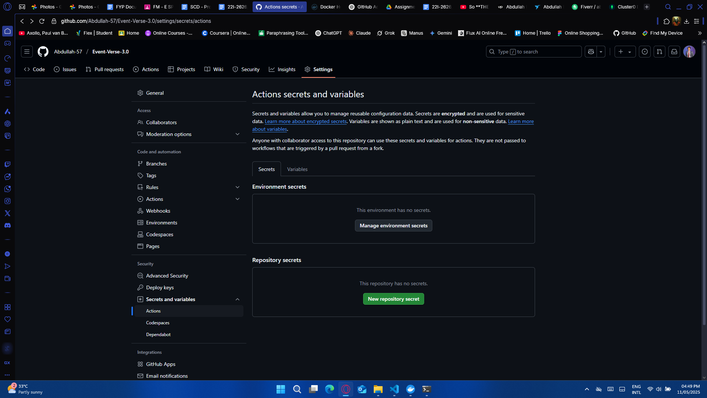

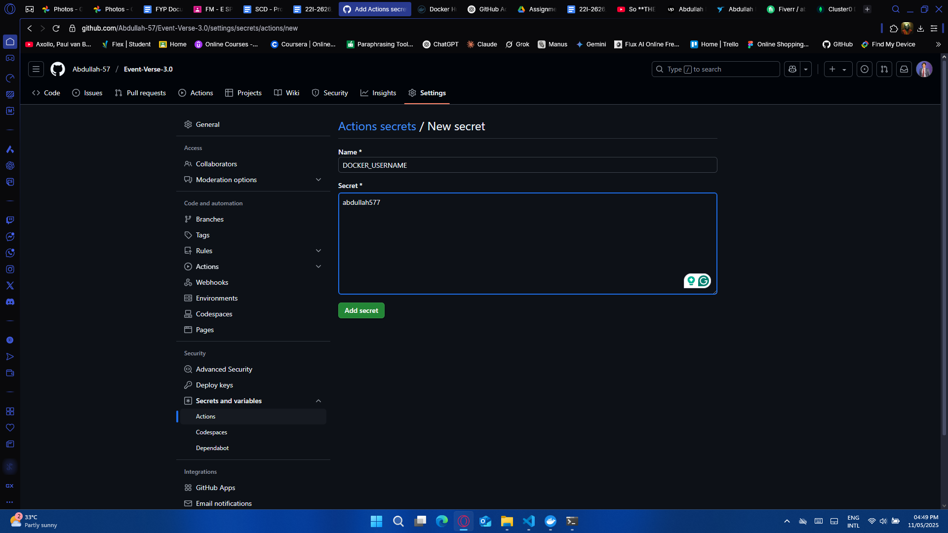

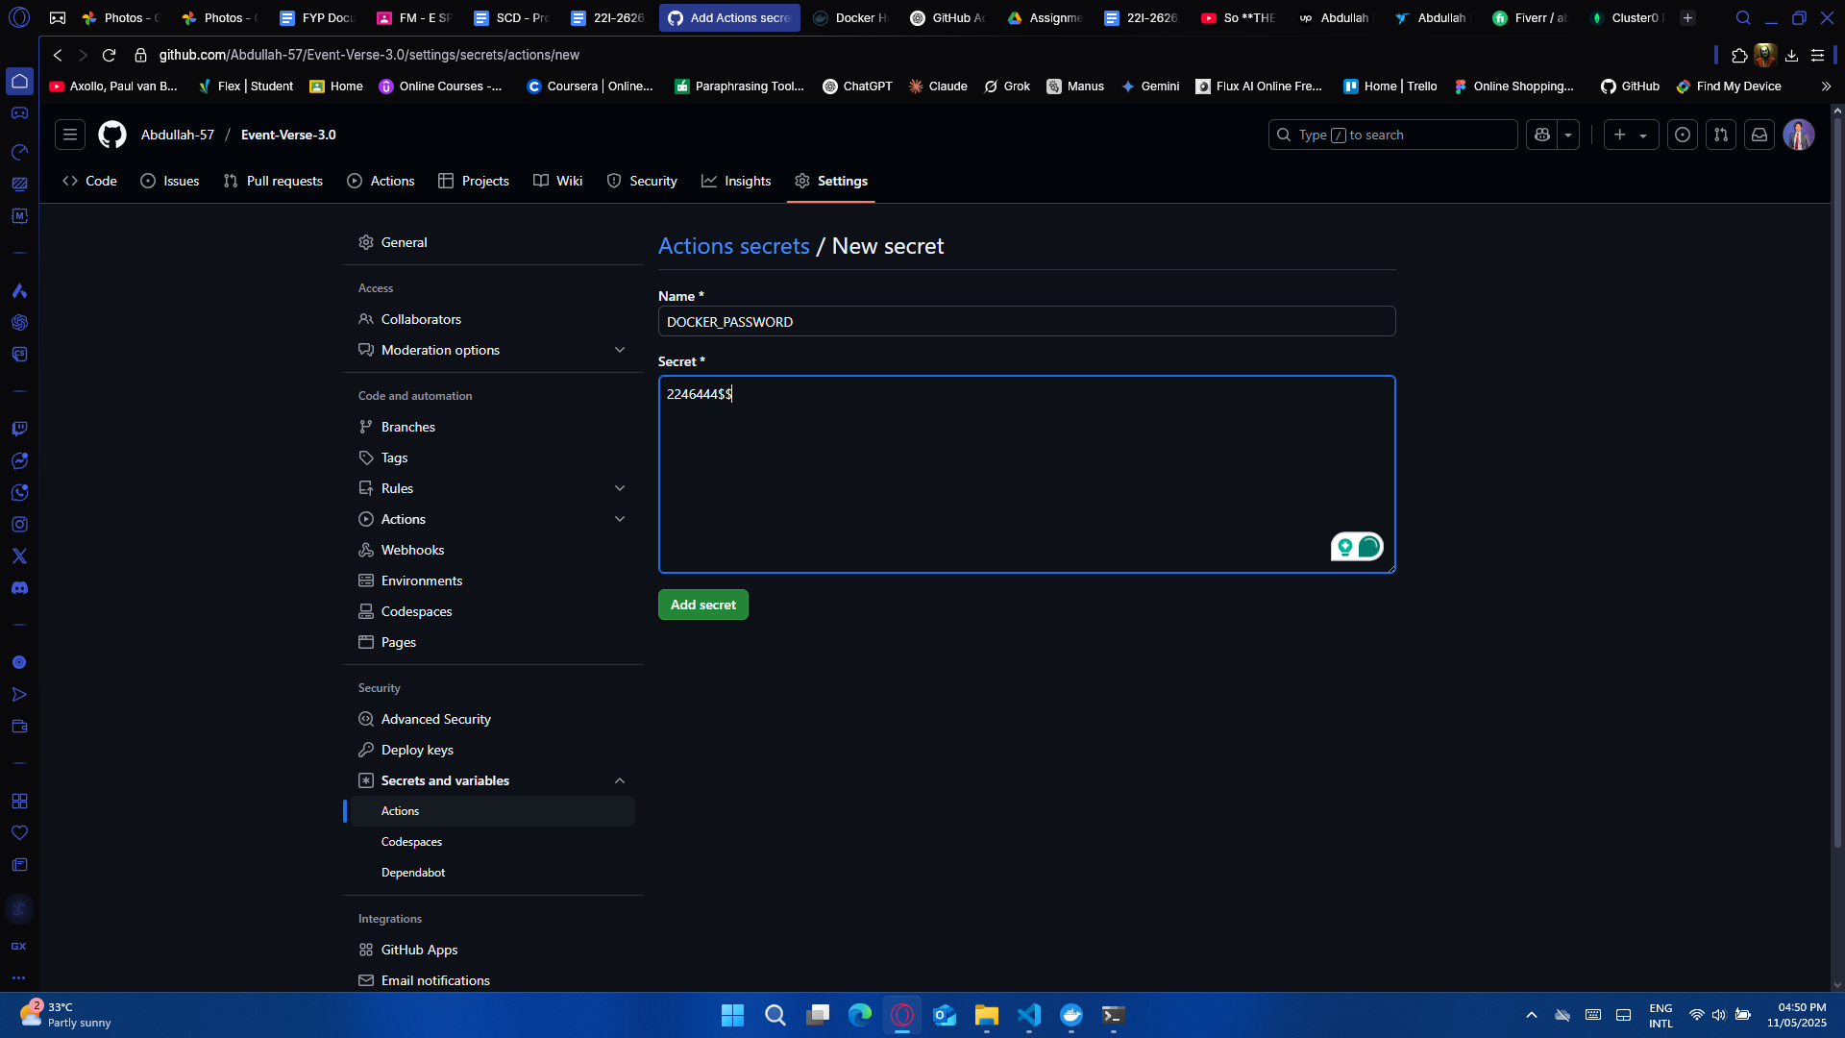

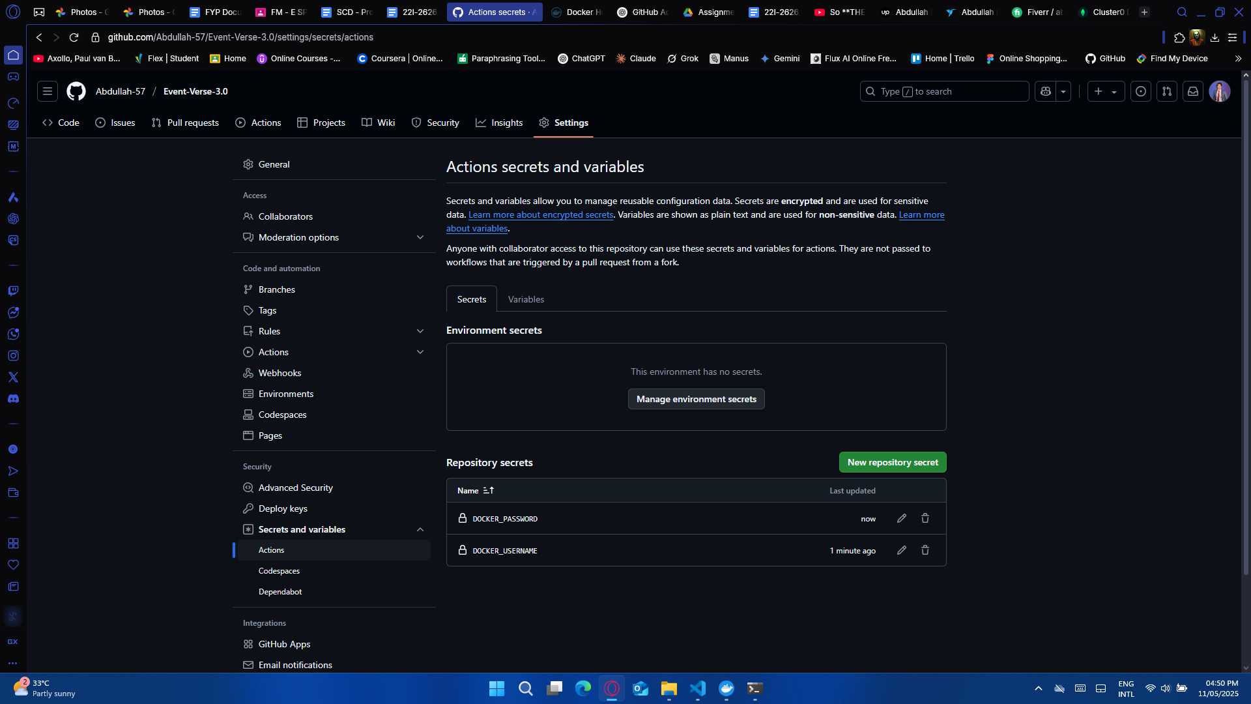

Now to trigger the workflow, all you have to do is push your project code to your github repository by running the following commands

git init (if not already initialized)

git add .

git commit -m “Commit Message” (Add any commit message)

git push origin main (This will trigger the workflow)

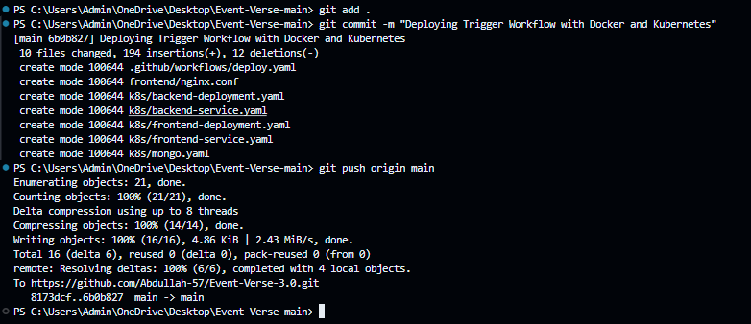

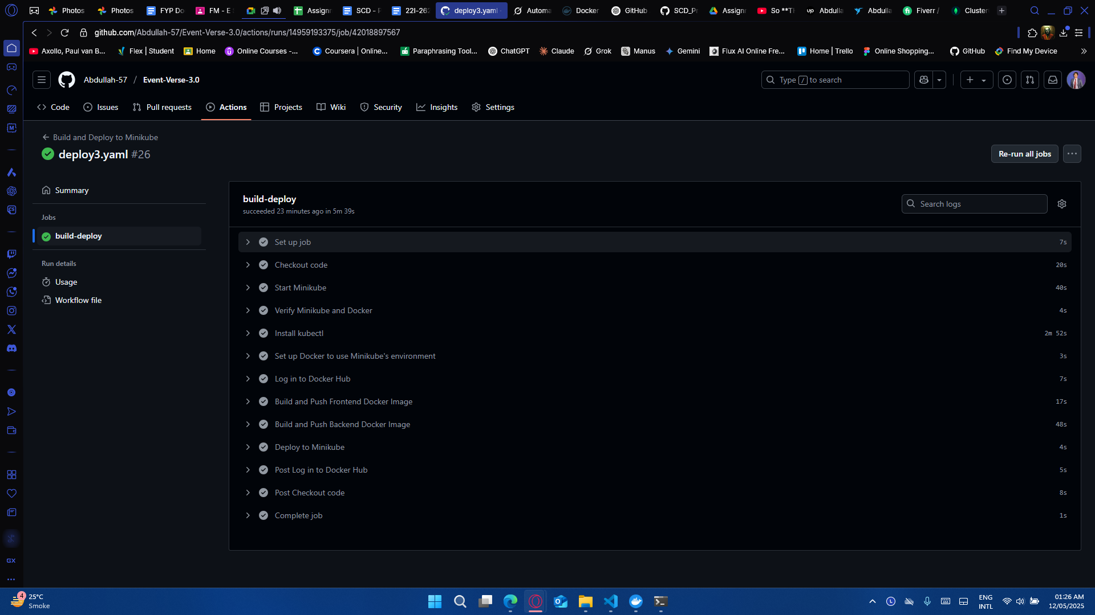

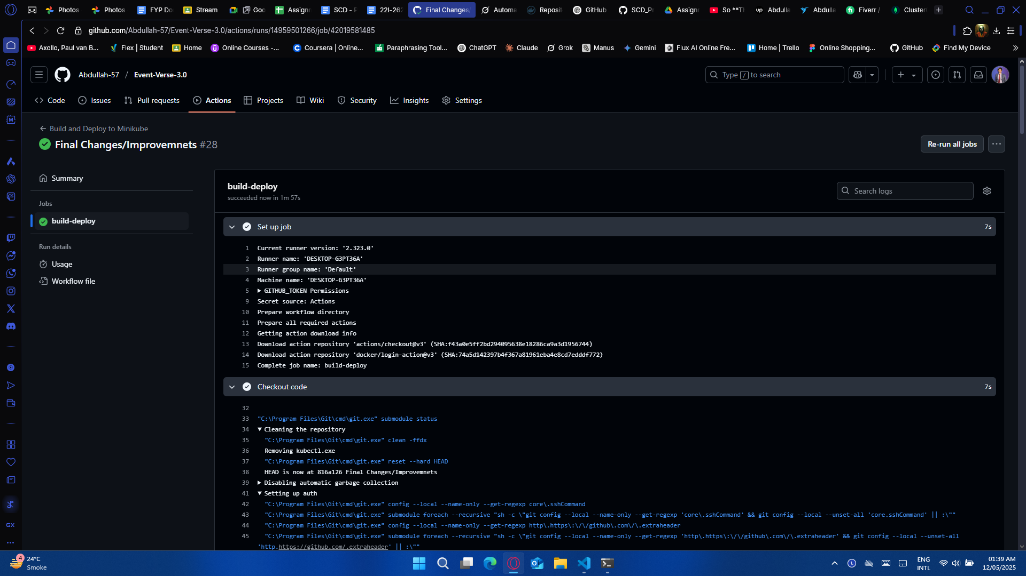

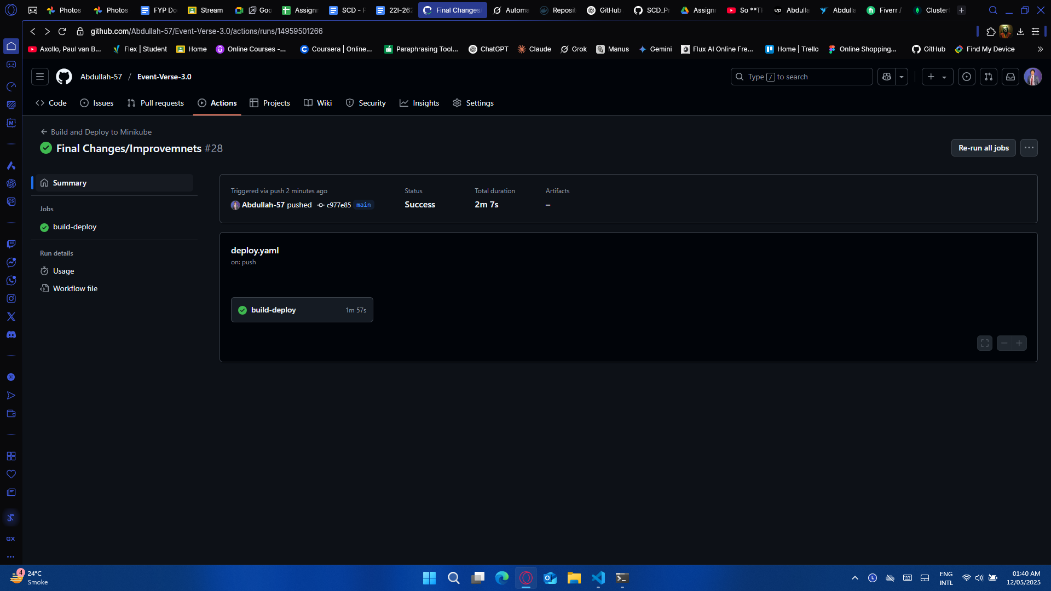

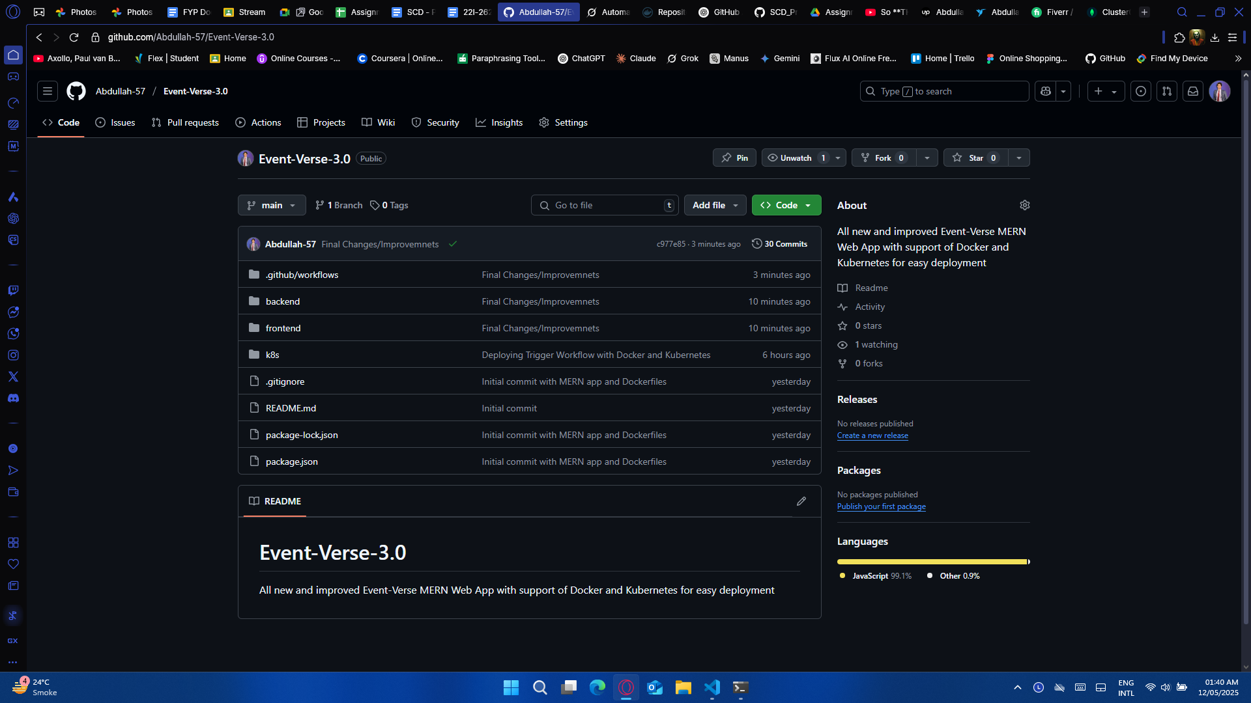

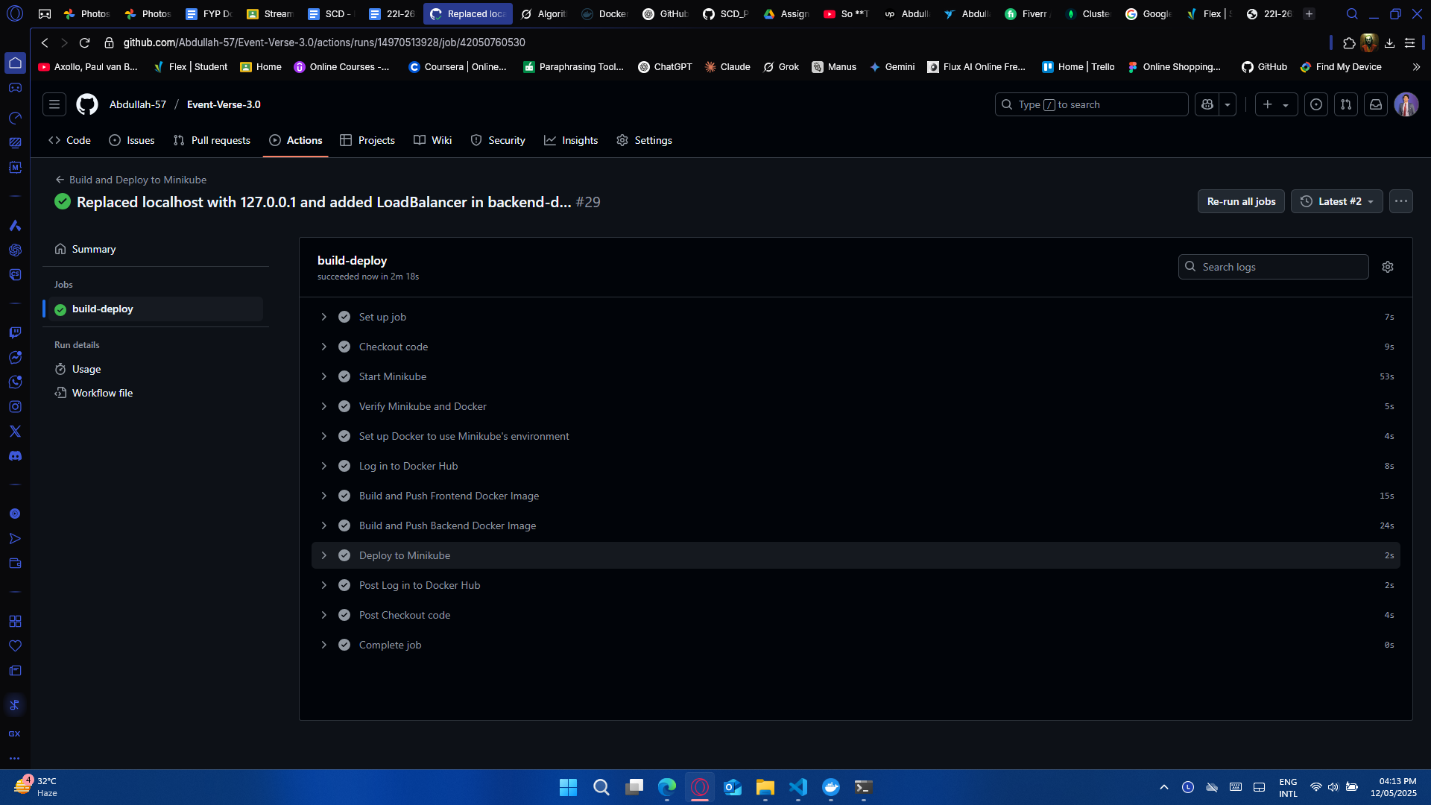

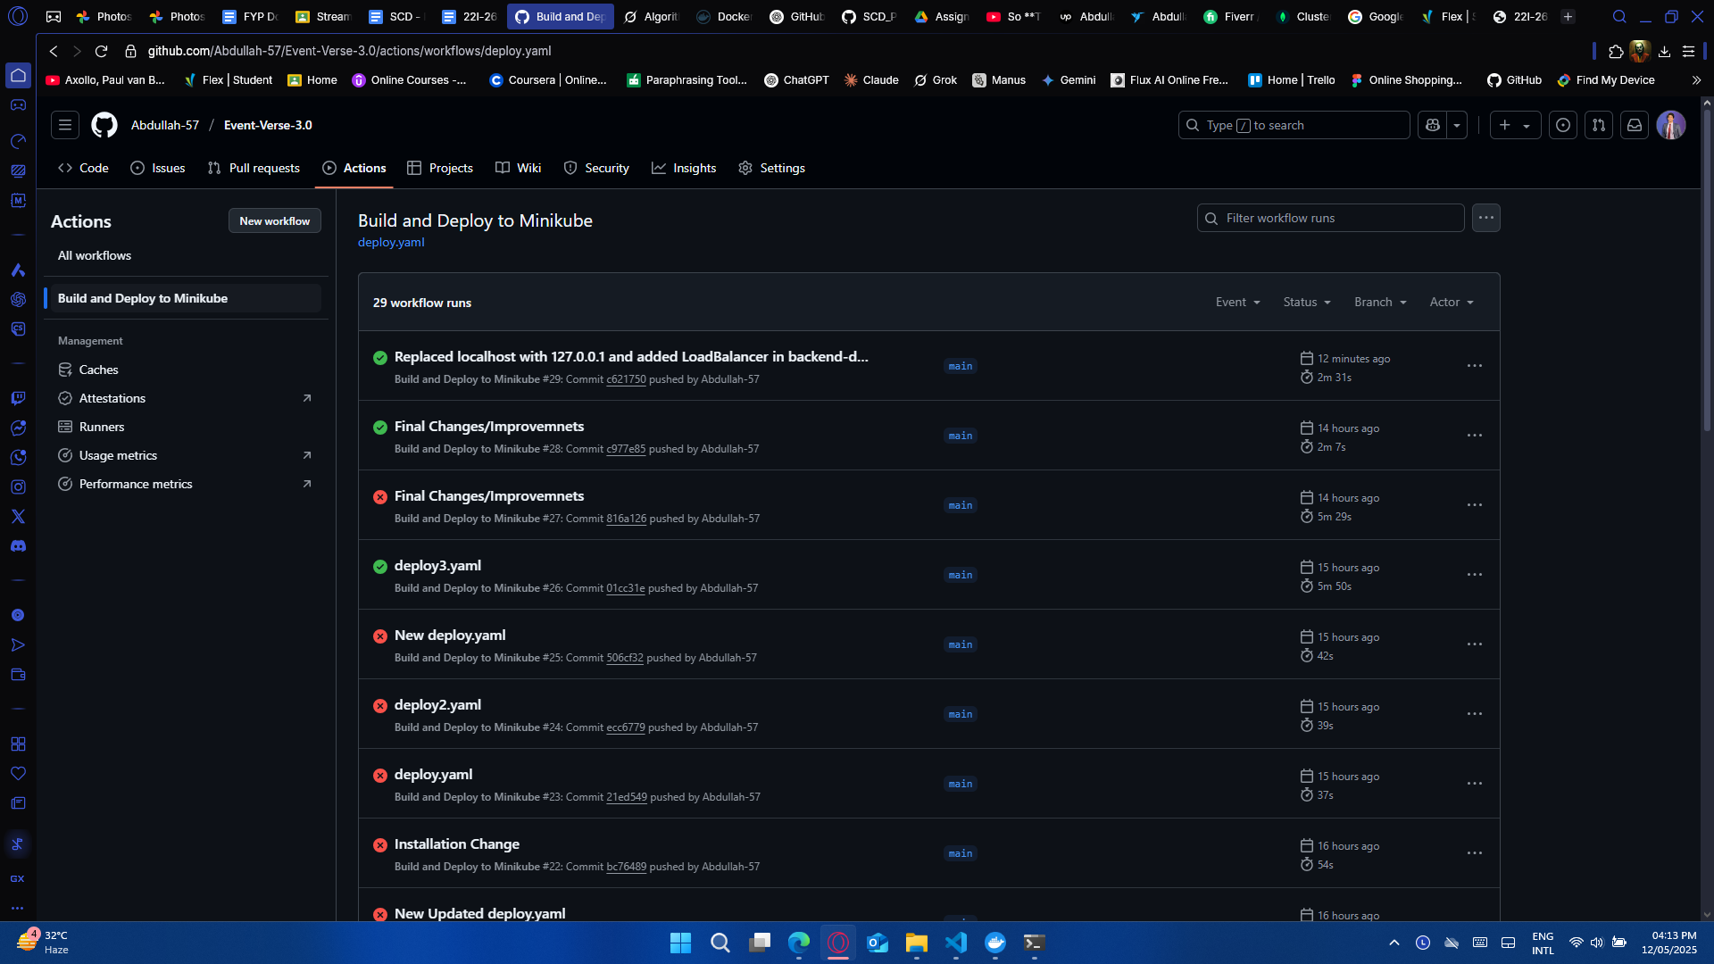

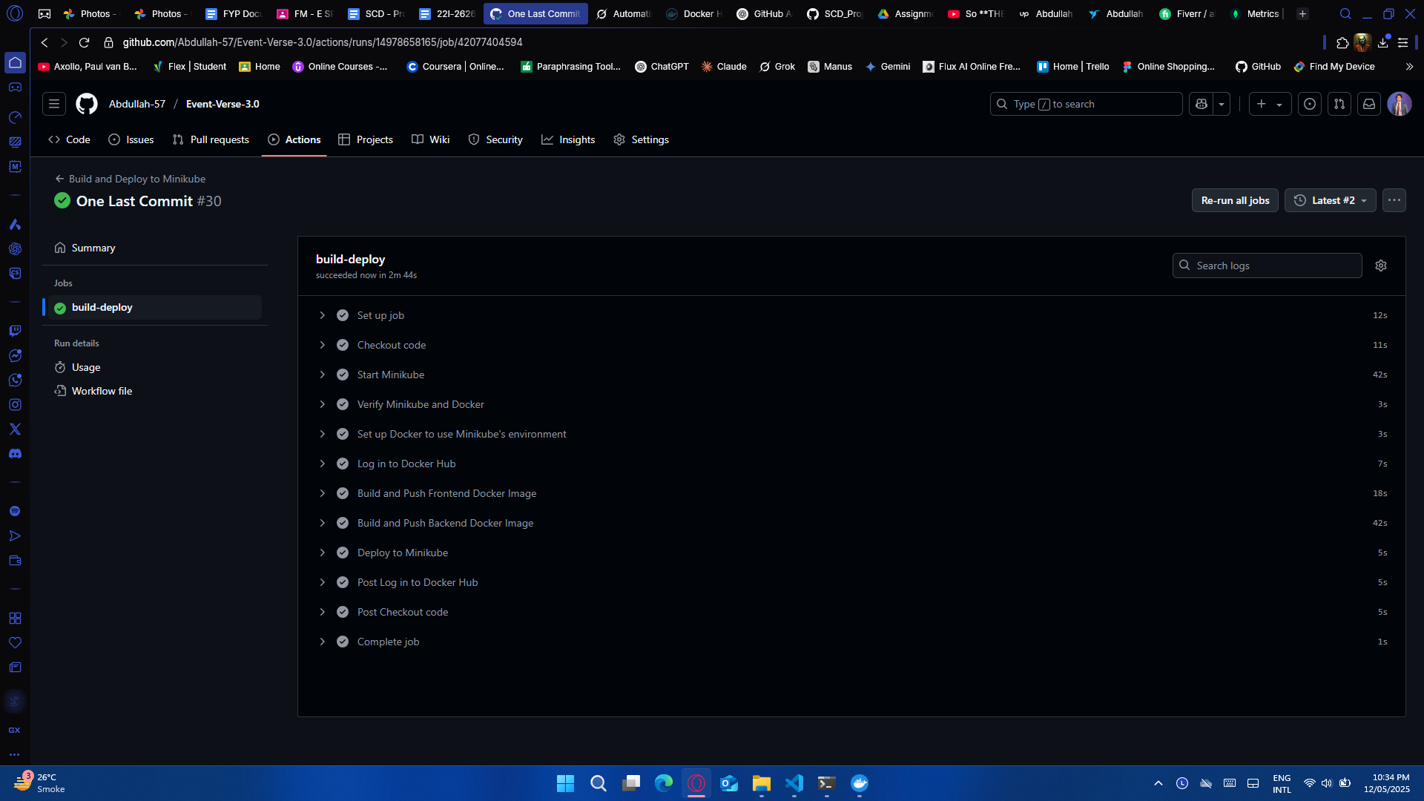

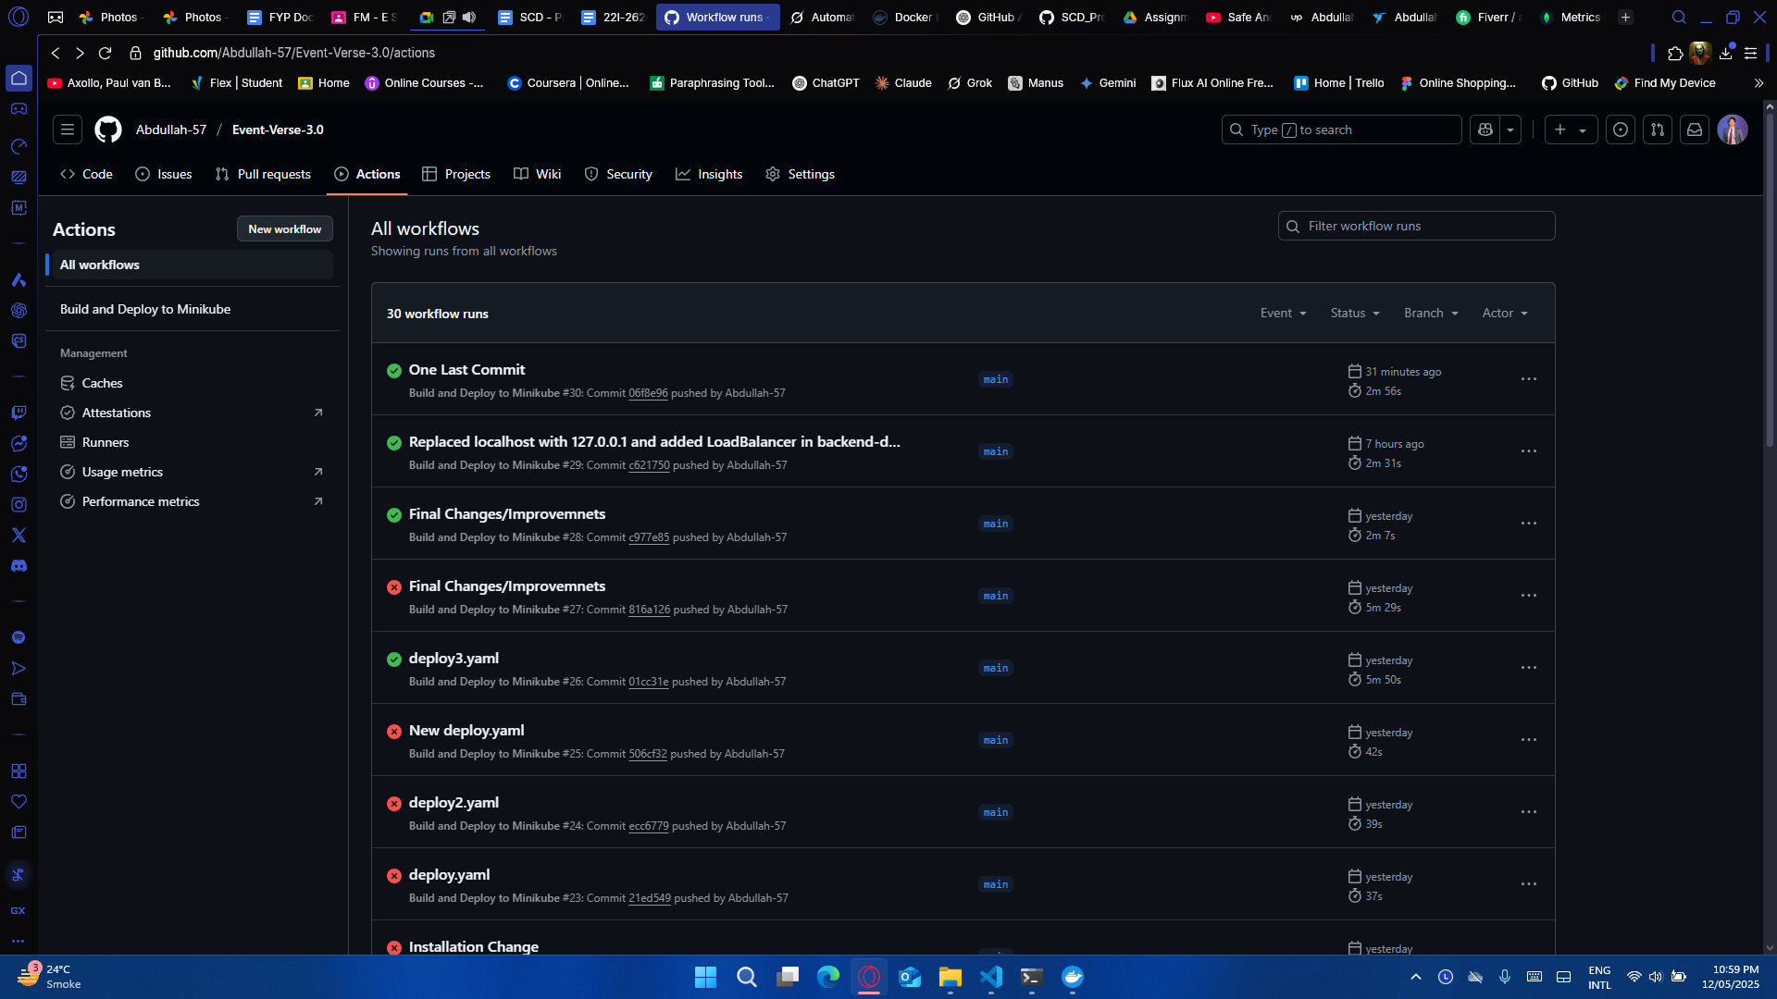

after running the workflow, run the following commands in Windows Powershell (preferred)

minikube service frontend-service -n scd-project

# Issue 6

App is successfully deployed using Kubernetes and Github Actions but the backend is unable to connect with the frontend for a full functional app

# Issue Resolved

Add the following line in the backend-deployment.yaml file:

type: LoadBalancer

Replace all the backend API fetch calls in frontend files that contain

[http://localhost:5000/api/………](http://localhost:5000/api/%E2%80%A6%E2%80%A6%E2%80%A6).

with

http://127.0.0.1:5000/api/………..

and then afer running the frontend-service with

minikube service frontend-service -n scd-project

create a tunnel to allow the backend to connect with the frontend

minikube tunnel

# Step 9: Trigger Local Deployment

kubectl create namespace scd-project

kubectl config set-context --current --namespace=scd-project

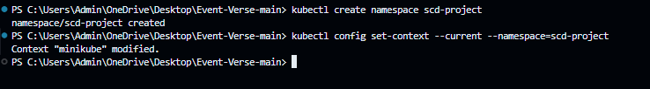

kubectl apply -f k8s/ --namespace=scd-project

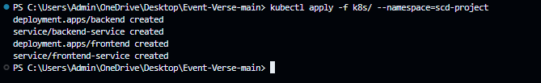

kubectl get pods

kubectl get svc

kubectl get deployments

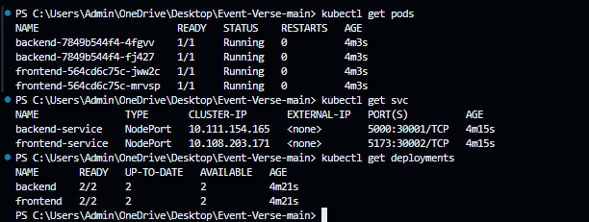

minikube service frontend-service -n scd-project

minikube tunnel

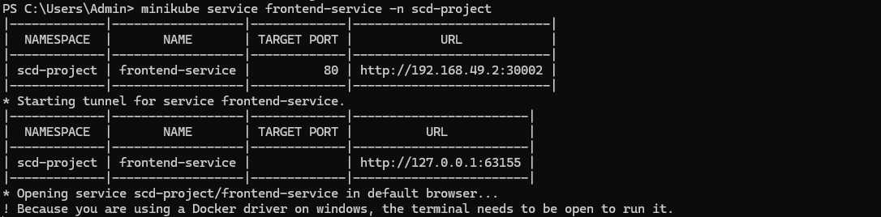

Some other helpful kubernetes commands:

kubectl get svc --all-namespaces

kubectl get pods -n scd-project

kubectl delete svc backend-service -n scd-project

kubectl delete svc frontend-service -n scd-project

kubectl logs backend-68cc6d9f4f-c9sz5 -n scd-project

kubectl rollout restart deployment backend -n scd-project

kubectl get pods -o wide Result:

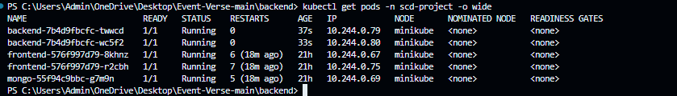

If a problem occurs where after running the workflow, backend crashes, do the following steps:

Make any change in the package.json file in backend

"scripts": {

"start": "node index.js"

}

After editing, rebuild the backend image:

cd backend

docker build -t abdullah577/mern-backend:latest .

docker push abdullah577/mern-backend:latest

Then re-apply your Kubernetes

kubectl rollout restart deployment backend -n scd-project

minikube service frontend-service -n scd-project

minikube tunnel

Fully functional app on minikube:

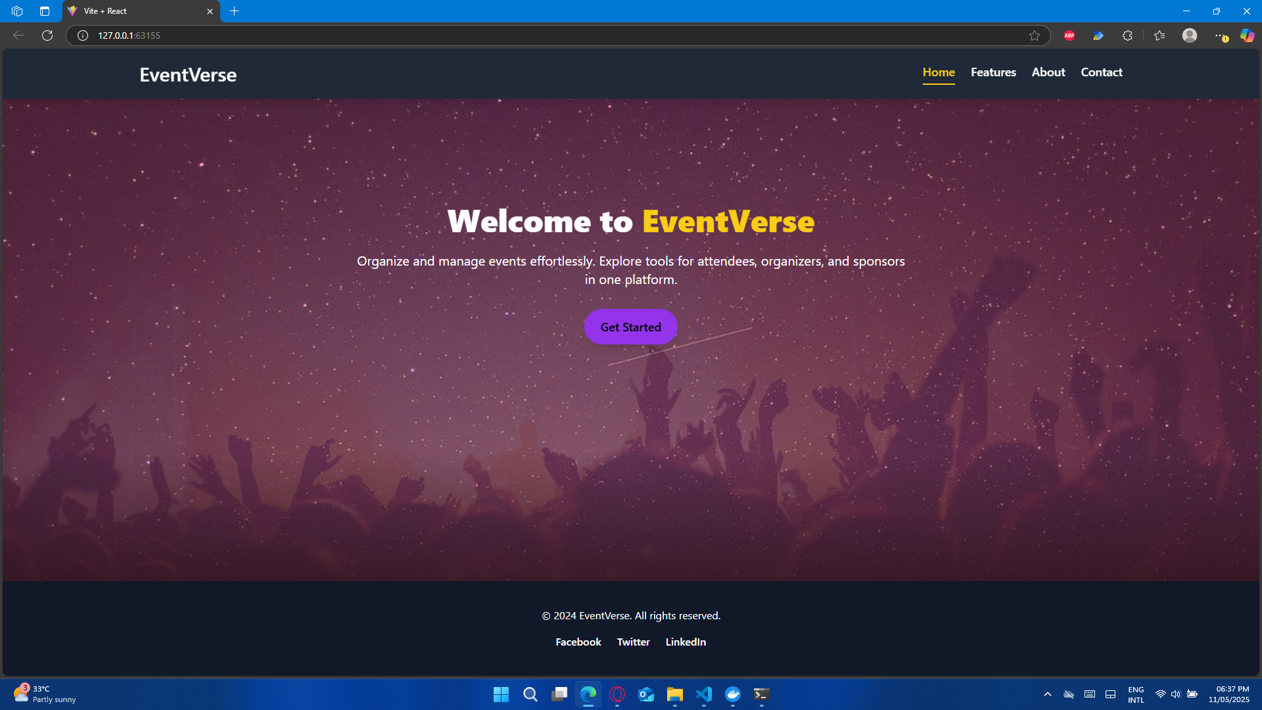

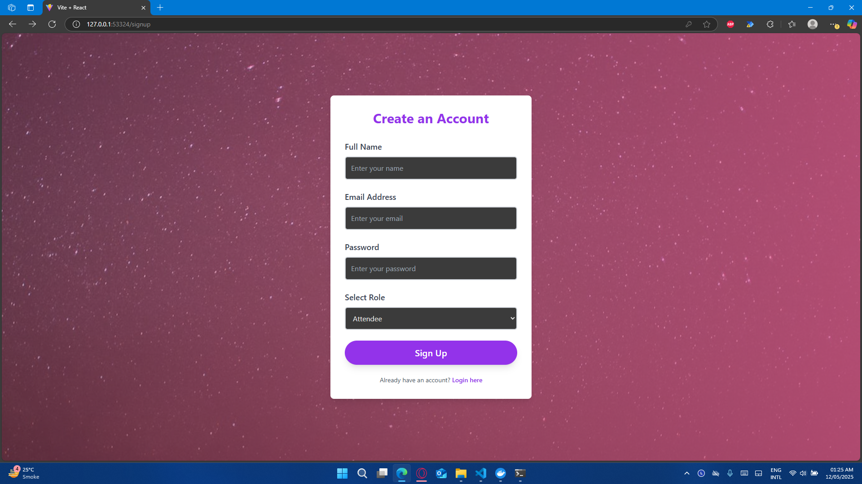

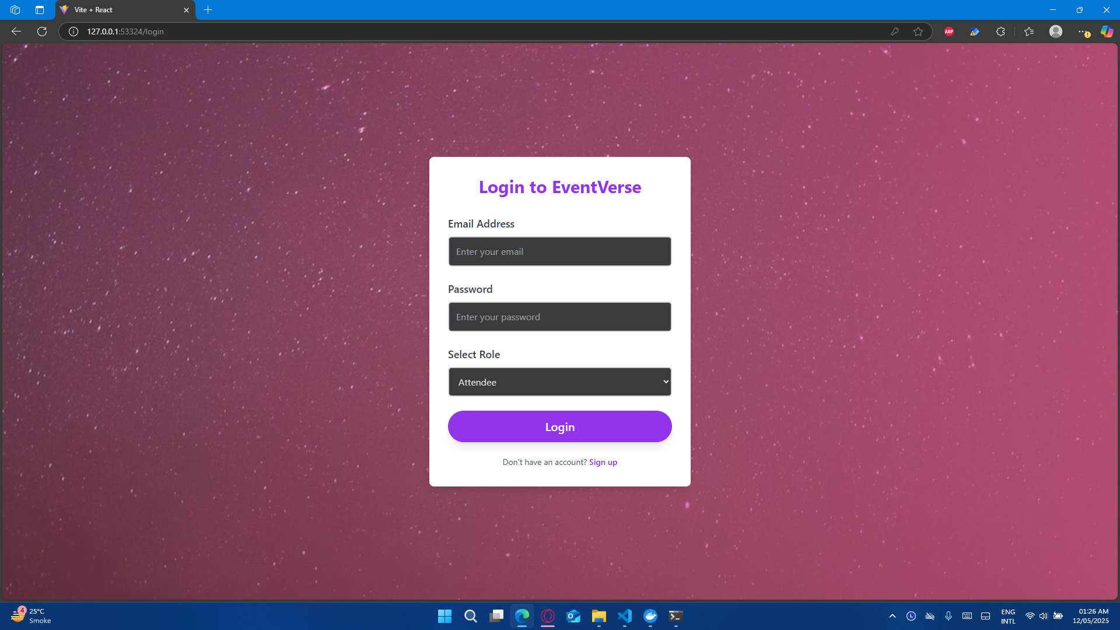

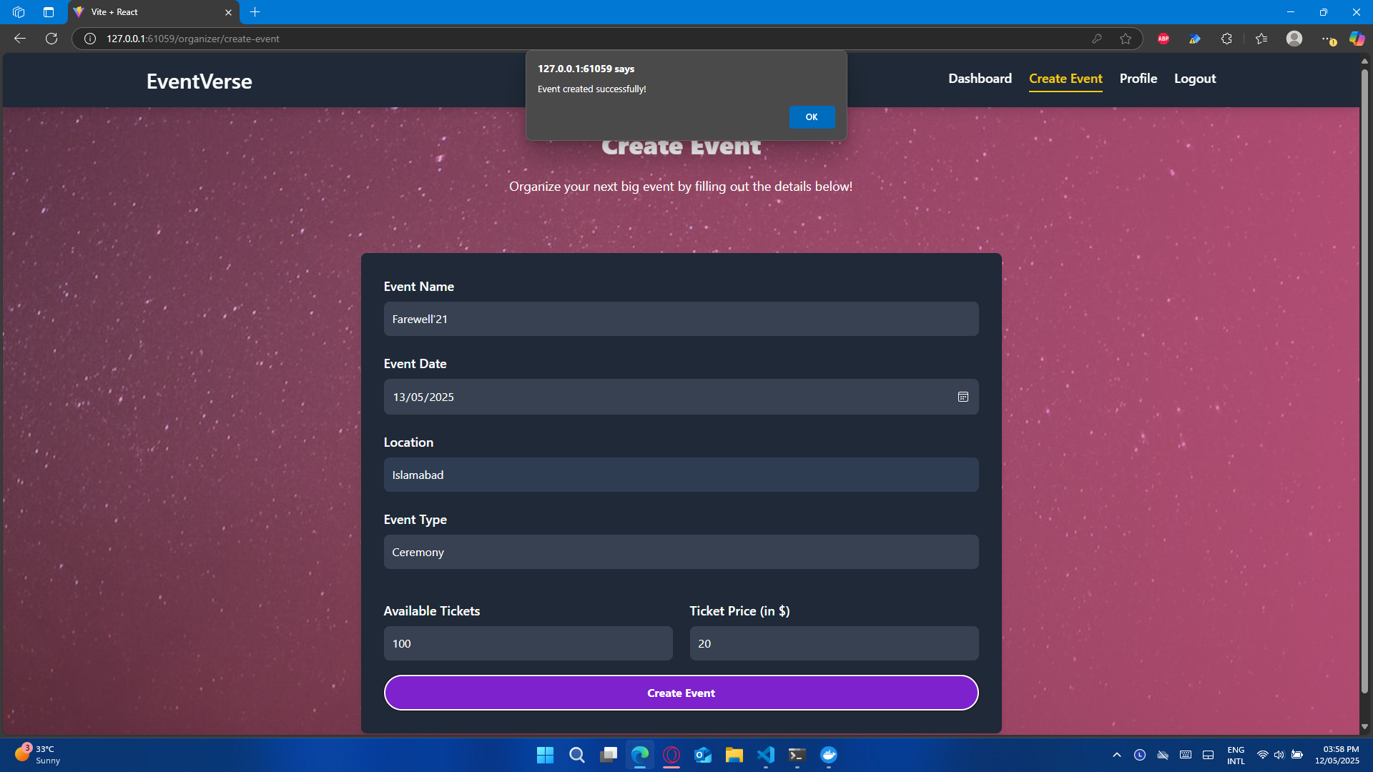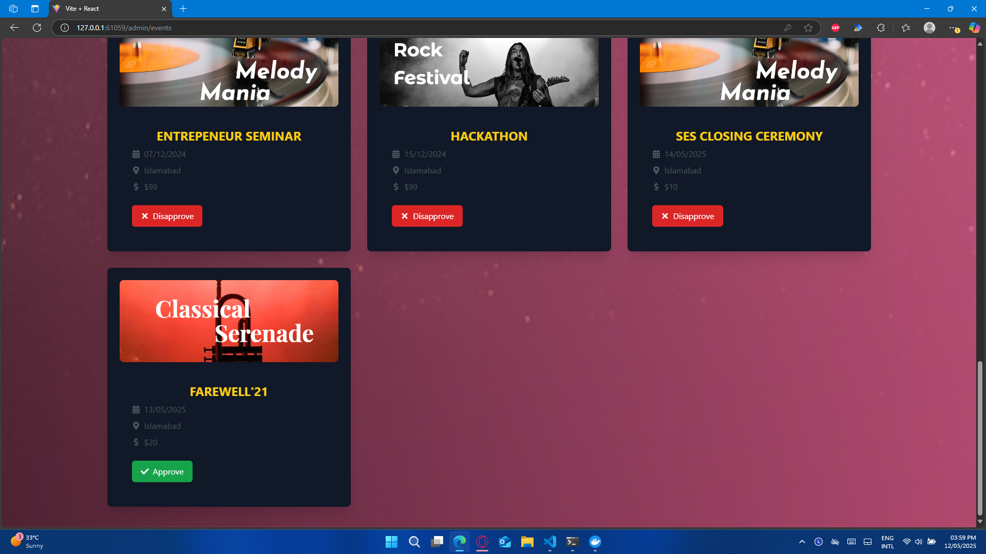

# Project Running Instructions

# Event-Verse-3.0 MERN Application with Kubernetes and Minikube

All new and improved Event-Verse-3.0 MERN Web App with support of Docker and Kubernetes for easy deployment. This project demonstrates a MERN (MongoDB, Express.js, React.js, Node.js) application deployed using Kubernetes and Minikube.

## Prerequisites

Ensure the following tools are installed on your machine:

- Docker

- Minikube

- kubectl

- Node.js 18+

- MongoDB Atlas account (for the database)

## Project Structure

```plaintext

.

├── frontend/ # React frontend application

├── backend/ # Node.js backend application

├── k8s/ # Kubernetes configuration files

│ ├── frontend-deployment.yaml

│ ├── backend-deployment.yaml

│ ├── frontend-service.yaml

│ ├── backend-service.yaml

│ └── mongo.yaml

└── .github/

└── workflows/

└── deploy.yml

```

Either follow Step 8 and Step 9 or if you want to run the app from scratch, follow these steps:

## Local Development

### Start the Frontend

```bash

cd frontend

npm install

npm run dev

```

### Start the Backend

```bash

cd backend

npm install

npm start

```

## Docker Build

Replace `your-dockerhub-username` with your Docker Hub username in the commands below.

### Build Frontend Image

```bash

cd frontend

docker build -t your-dockerhub-username/mern-frontend:latest .

```

### Build Backend Image

```bash

cd backend

docker build -t your-dockerhub-username/mern-backend:latest .

```

## Kubernetes Deployment

### Start Minikube

```bash

minikube start

```

### Create Namespace

```bash

kubectl create namespace scd-project

```

### Create MongoDB Secret

Replace `your-mongodb-uri` with your MongoDB Atlas connection string.

```bash

kubectl create secret generic mongodb-secret --namespace scd-project --from-literal=uri=your-mongodb-uri

```

### Deploy the Application

```bash

cd k8s

kubectl apply -f frontend-deployment.yaml

kubectl apply -f backend-deployment.yaml

kubectl apply -f frontend-service.yaml

kubectl apply -f backend-service.yaml

kubectl apply -f mongo.yaml

```

### Access the Application

```bash

minikube service frontend-service -n scd-project

```

## GitHub Actions Setup

1. Add the following secrets to your GitHub repository (Settings &gt; Secrets and variables &gt; Actions):

- `DOCKER_USERNAME`: Your Docker Hub username

- `DOCKER_PASSWORD`: Your Docker Hub password or access token

- `MONGODB_URI`: Your MongoDB Atlas connection string

2. Set up a self-hosted runner on the machine where Minikube is running. Follow the instructions in your repository’s Settings &gt; Actions &gt; Runners.

3. Push your code to the `main` branch to trigger the deployment.

## Monitoring

### Check Pod Status

```bash

kubectl get pods -n scd-project

```

### Check Services

```bash

kubectl get services -n scd-project

```

### Check Deployments

```bash

kubectl get deployments -n scd-project

```

## Troubleshooting

### View Pod Logs

Replace `<pod-name>` with the name of the pod (obtained from `kubectl get pods -n mern-app`).

```bash

kubectl logs <pod-name> -n scd-project

```

### Describe Resources

```bash

kubectl describe pod <pod-name> -n scd-project

kubectl describe service <service-name> -n scd-project

```

## Cleanup

### Delete the Deployment

```bash

kubectl delete -f k8s/

```

### Delete the Namespace

```bash

kubectl delete namespace scd-project

```

### Stop Minikube

```bash

minikube stop

```

Final Github Repository:

https://github.com/Abdullah-57/Event-Verse-3.0

